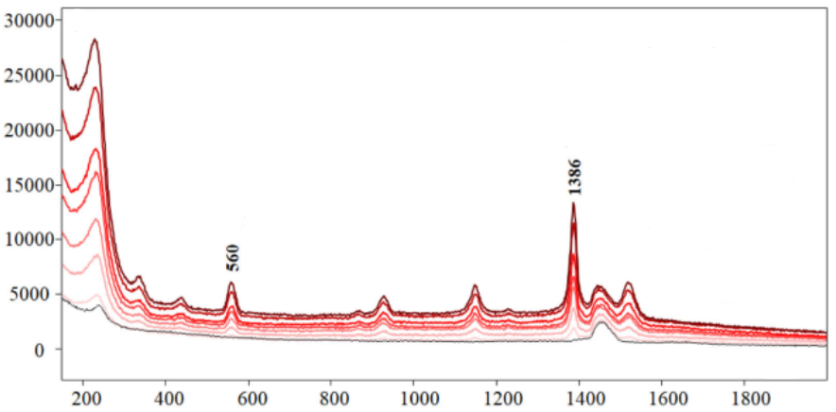

*Figure 1:https://doi.org/10.1002/jrs.6222*

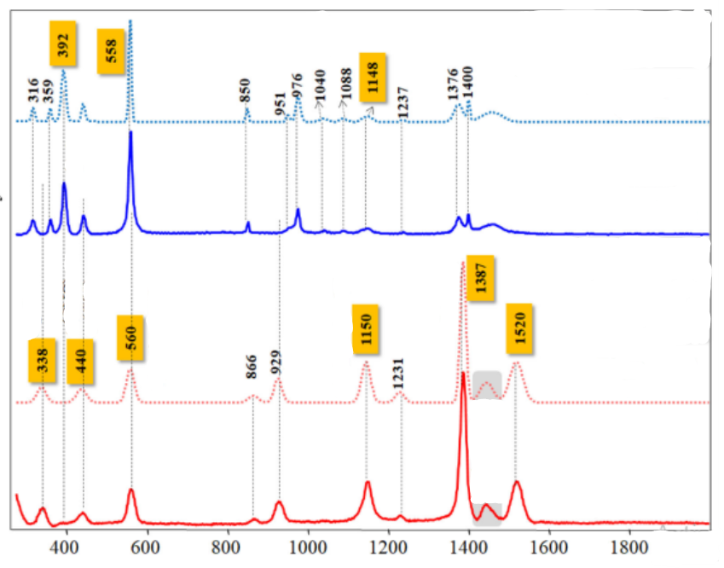

*Figure 2:https://doi.org/10.1002/jrs.6222*

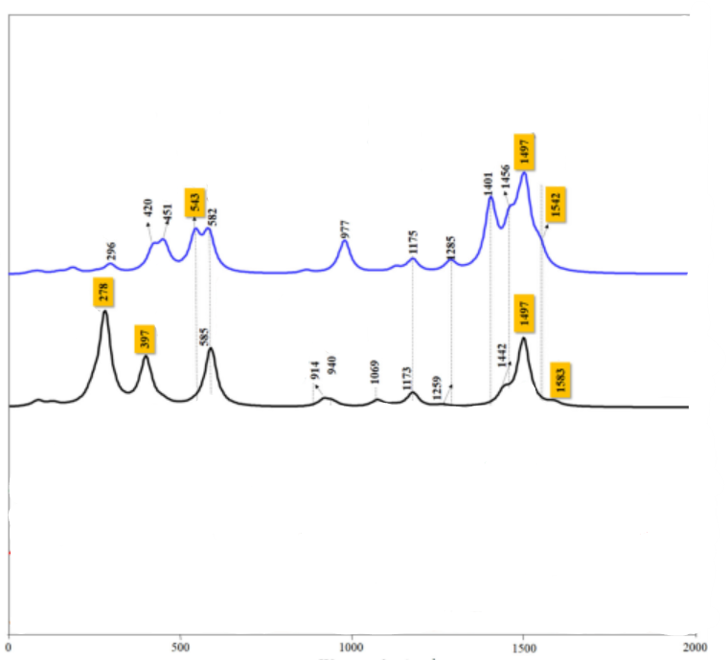

*Figure 3:https://doi.org/10.1002/jrs.6222*

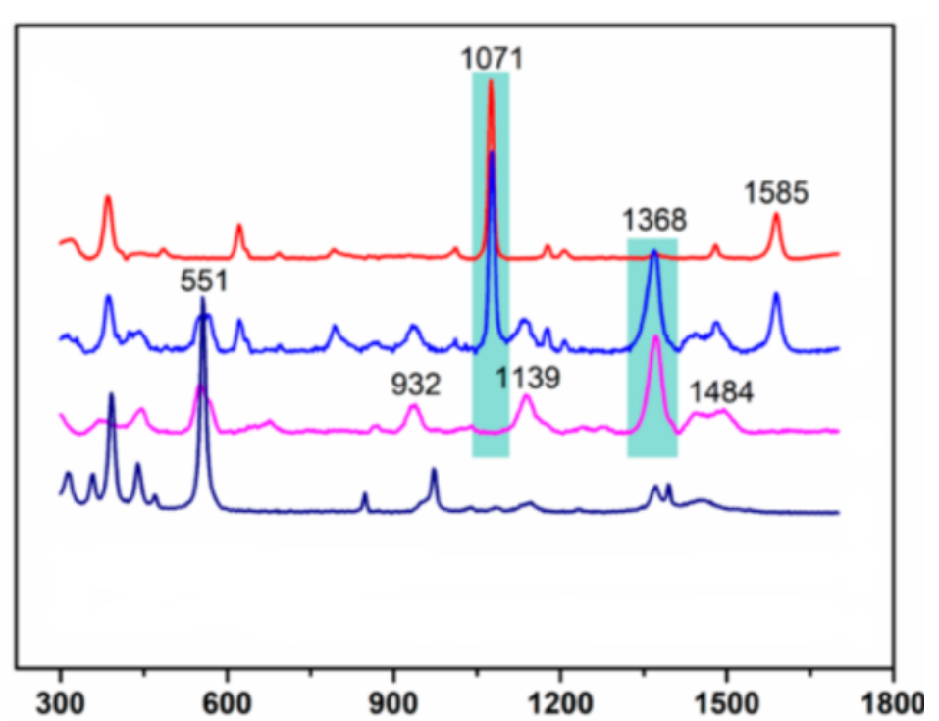

*Figure 4:https://doi.org/10.1021/acs.analchem.8b03940*

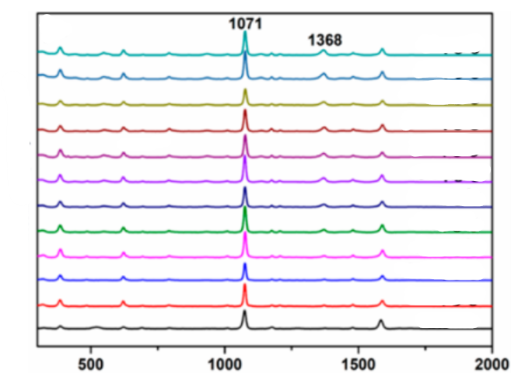

*Figure 5:https://doi.org/10.1021/acs.analchem.8b03940*

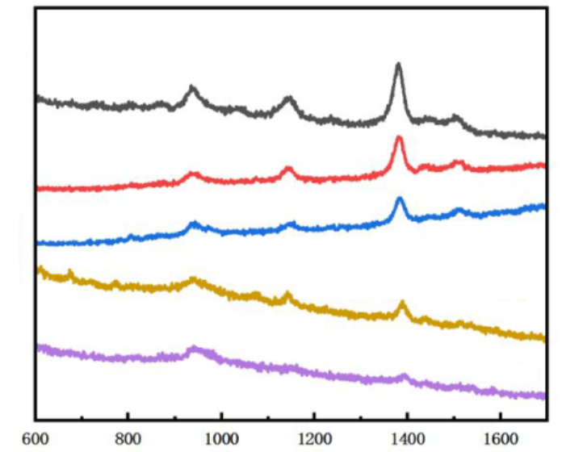

Figure 6: <https://doi.org/10.1021/acsanm.5c01351>

*Figure 7:https://doi.org/10.3390/foods11223597*

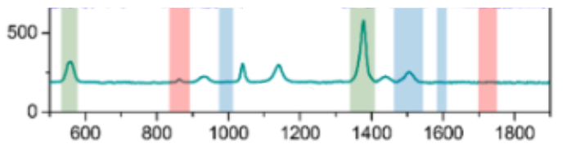

*Figure 8:https://doi.org/10.3390/foods11223597*

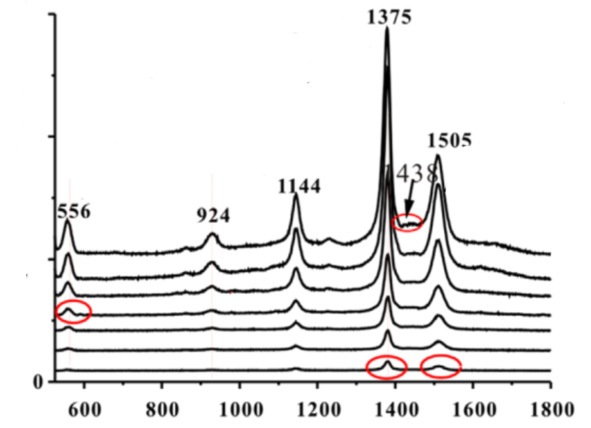

*Figure 9:https://doi.org/10.1016/j.talanta.2013.08.050*

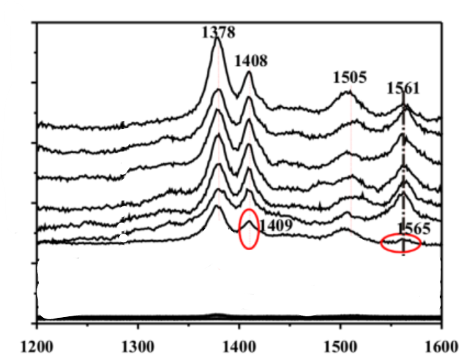

*Figure 10:https://doi.org/10.1016/j.talanta.2013.08.050*

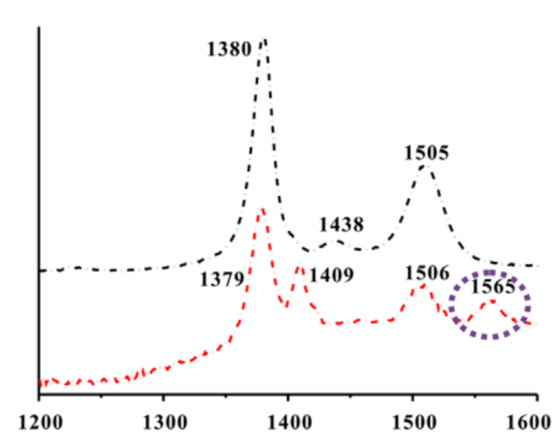

*Figure 11:https://doi.org/10.1016/j.talanta.2013.08.050*

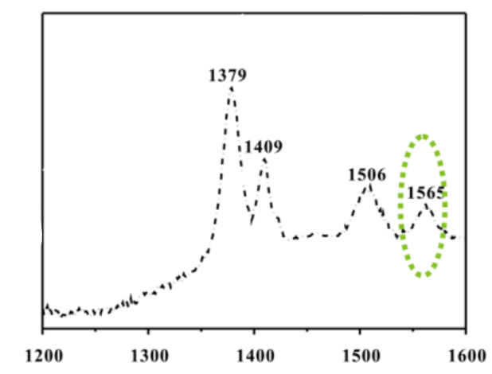

*Figure 12:https://doi.org/10.1016/j.talanta.2013.08.050*

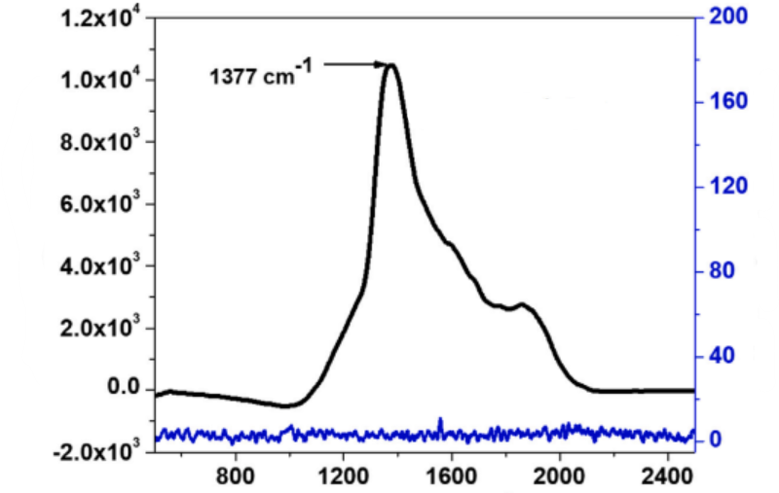

*Figure 13:https://doi.org/10.1016/j.matchemphys.2022.127088*

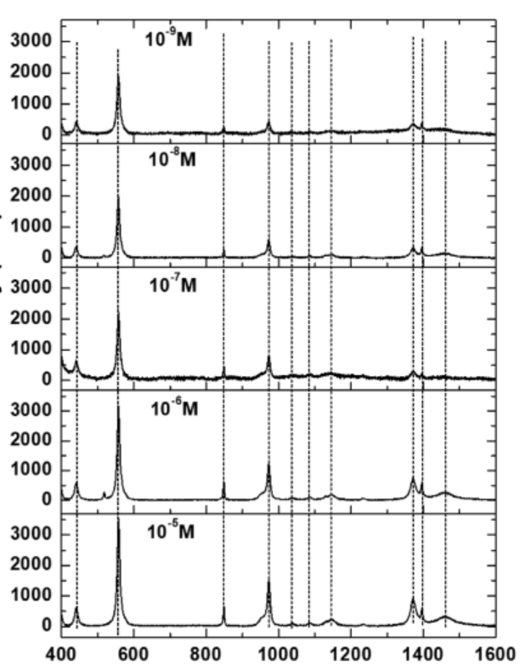

*Figure 14:https://doi.org/10.1016/j.matchemphys.2022.127088*

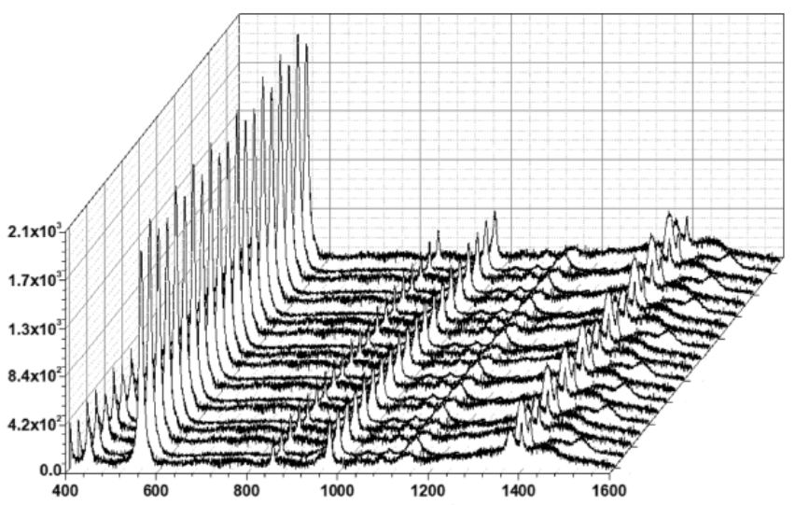

*Figure 15:https://doi.org/10.1016/j.matchemphys.2022.127088*

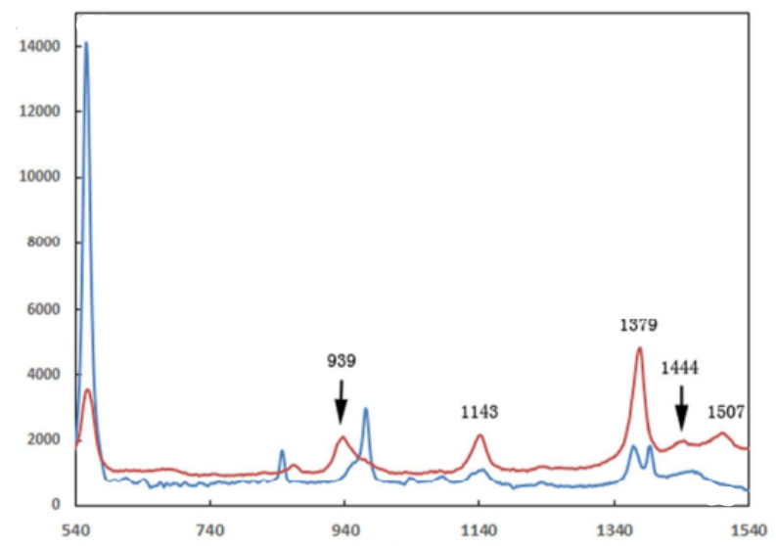

*Figure 16:https://doi.org/10.1039/C7AY01637A*

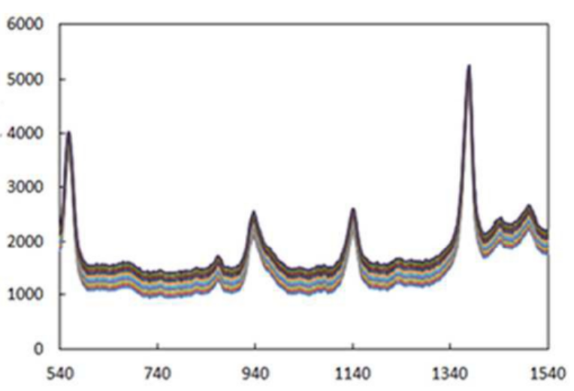

*Figure 17:https://doi.org/10.1039/C7AY01637A*

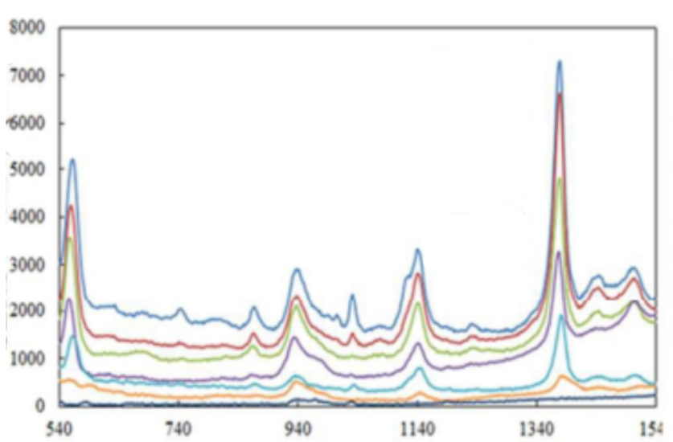

*Figure 18:https://doi.org/10.1039/C7AY01637A*

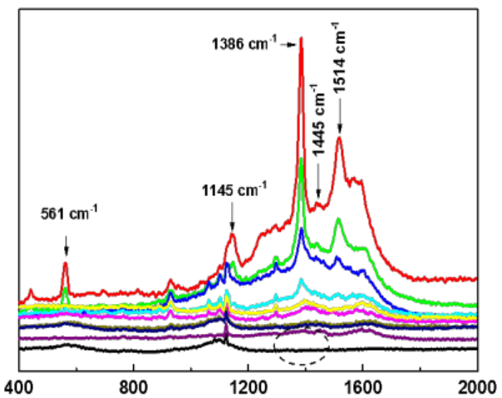

*Figure 19:https://doi.org/10.1039/C4NR06429A*

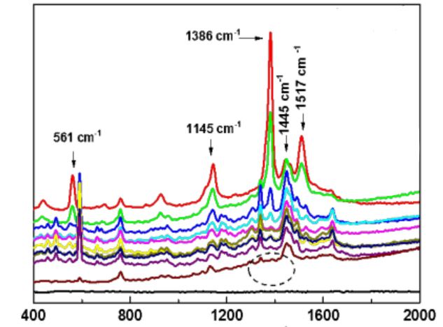

*Figure 20:https://doi.org/10.1039/C4NR06429A*



*Figure 21:https://doi.org/10.1016/S0924-2031(98)00025-3*

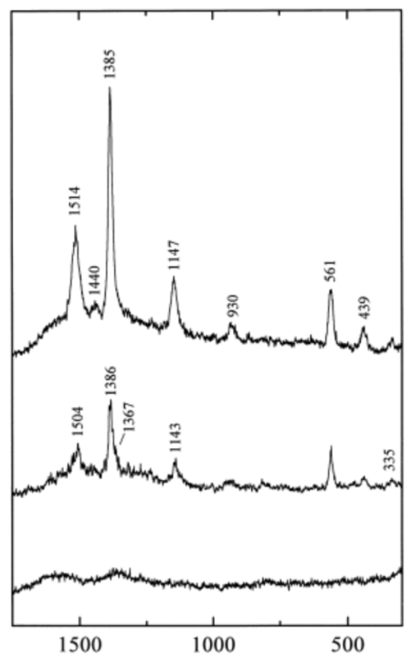

*Figure 22:https://doi.org/10.1016/S0924-2031(98)00025-3*

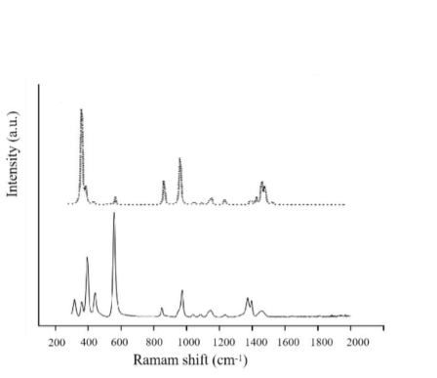

*Figure 23:https://doi.org/10.1016/j.foodchem.2025.145302*

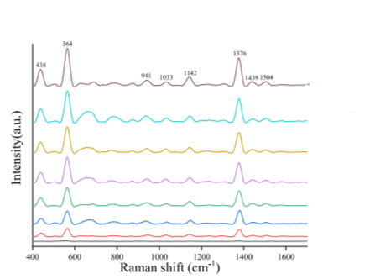

*Figure 24:https://doi.org/10.1016/j.foodchem.2025.145302*

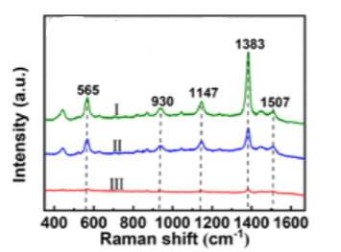

*Figure 25:https://doi.org/10.1021/acsanm.2c05351*

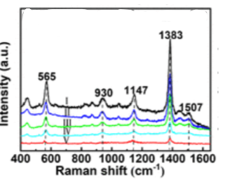

*Figure 26:https://doi.org/10.1021/acsanm.2c05351*

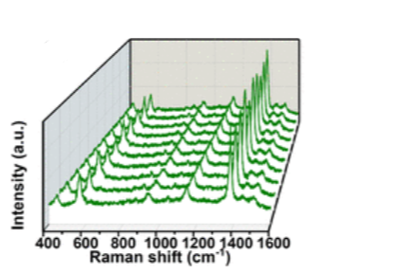

*Figure 27:https://doi.org/10.1021/acsanm.2c05351*

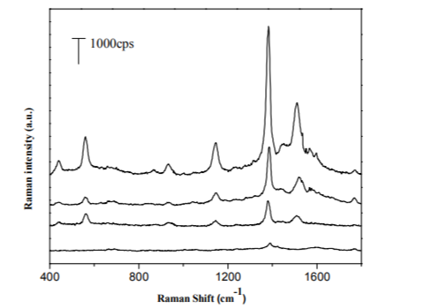

*Figure 28:https://doi.org/10.1039/C5RA13080H*

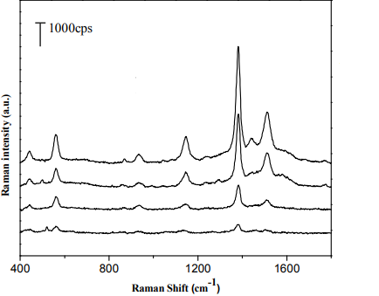

*Figure 29:https://doi.org/10.1039/C5RA13080H*

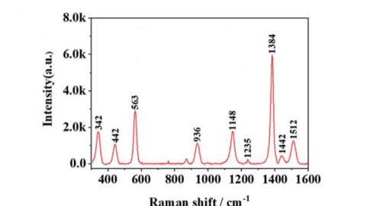

*Figure 30:https://doi.org/10.1039/D0AY01953D*

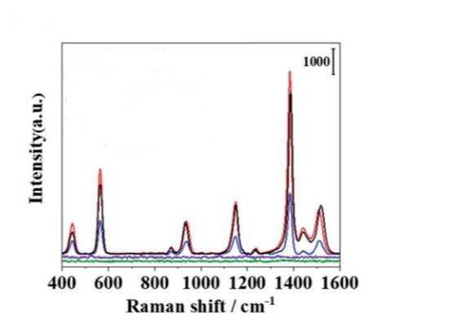

*Figure 31:https://doi.org/10.1039/D0AY01953D*

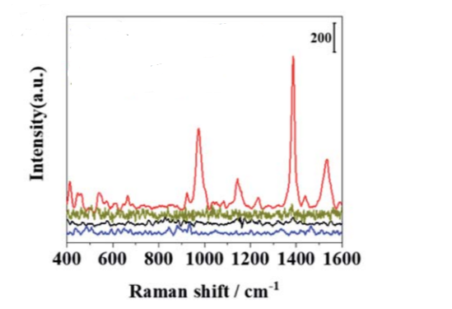

*Figure 32:https://doi.org/10.1039/D0AY01953D*

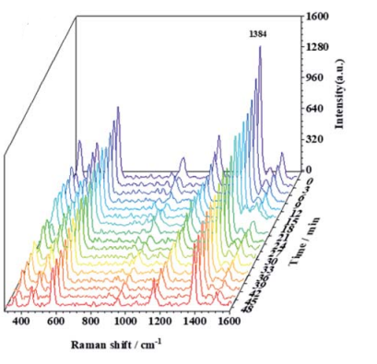

*Figure 33:https://doi.org/10.1039/D0AY01953D*

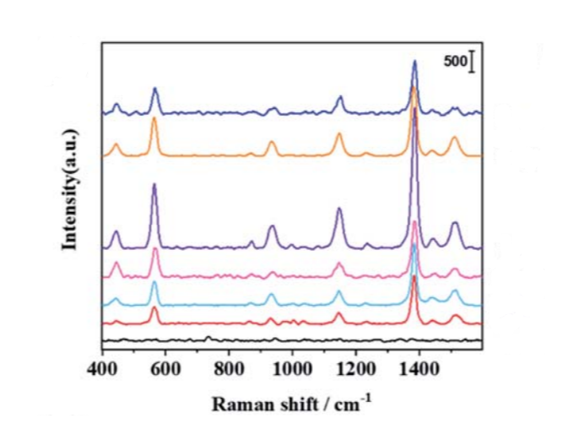

*Figure 34:https://doi.org/10.1039/D0AY01953D*

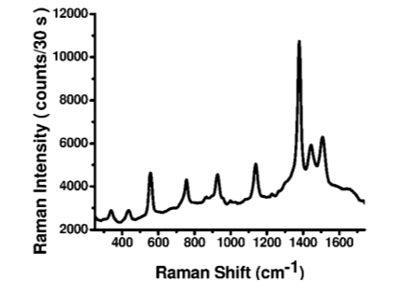

*Figure 35:https://doi.org/10.1039/C0AN00594K*

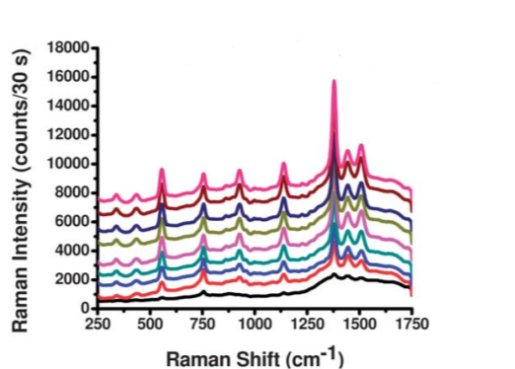

*Figure 36:https://doi.org/10.1039/C0AN00594K*

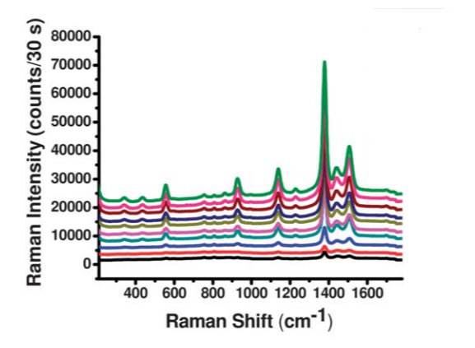

*Figure 37:https://doi.org/10.1039/C0AN00594K*

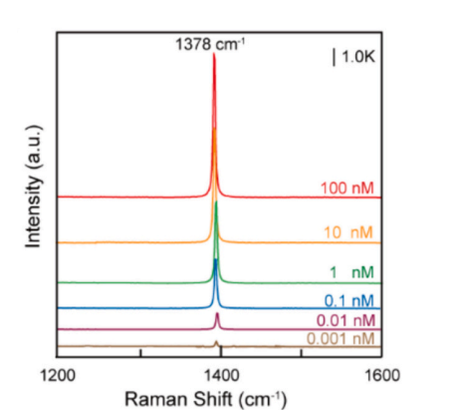

*Figure 38:https://doi.org/10.1016/j.foodchem.2024.139852*

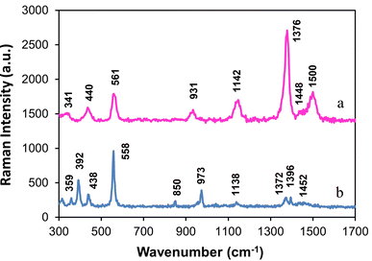

*Figure 39:https://doi.org/10.1039/D3AN01449E*

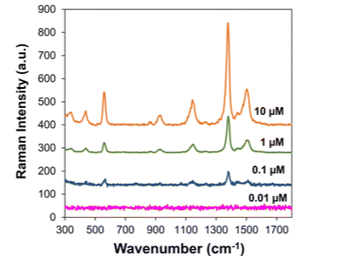

*Figure 40:https://doi.org/10.1039/D3AN01449E*

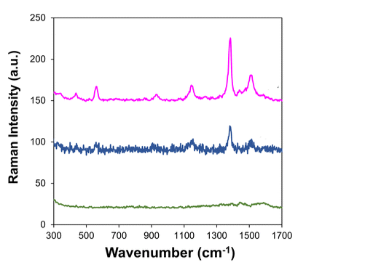

*Figure 41:https://doi.org/10.1039/D3AN01449E*

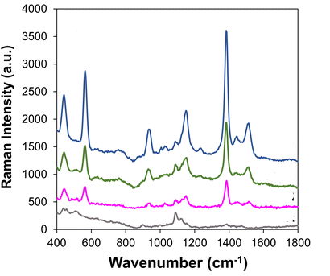

*Figure 42:* [*https://doi.org/10.1039/D3AN01449E*](https://doi.org/10.1039/D3AN01449E)

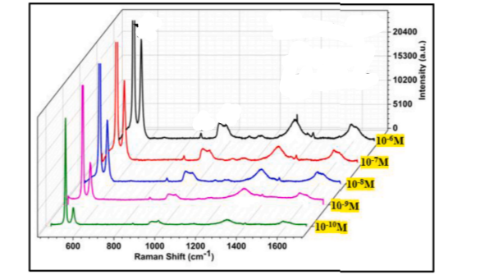

*Figure 43:https://doi.org/10.1016/j.optmat.2024.115647*

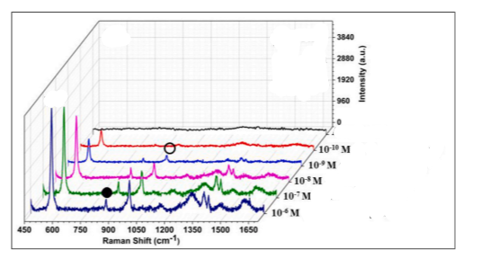

*Figure 44:https://doi.org/10.1016/j.optmat.2024.115647*

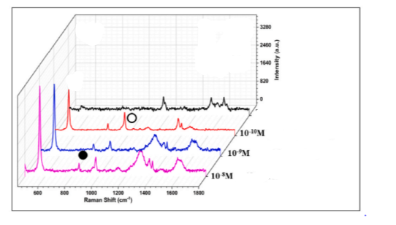

*Figure 45:https://doi.org/10.1016/j.optmat.2024.115647*

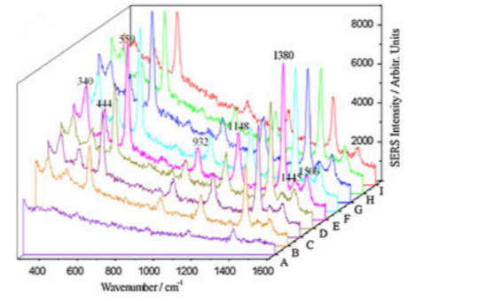

*Figure 46:https://doi.org/10.1002/jrs.4087*

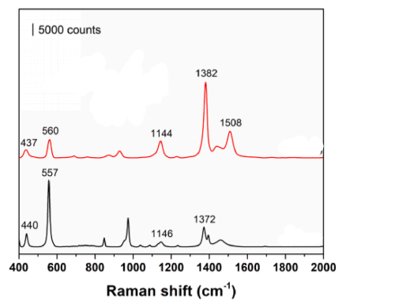

*Figure 47:https://doi.org/10.1016/j.foodchem.2020.128548*

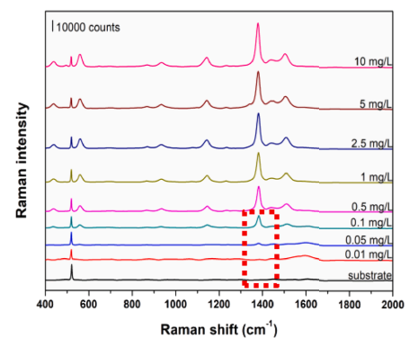

*Figure 48:https://doi.org/10.1016/j.foodchem.2020.128548*

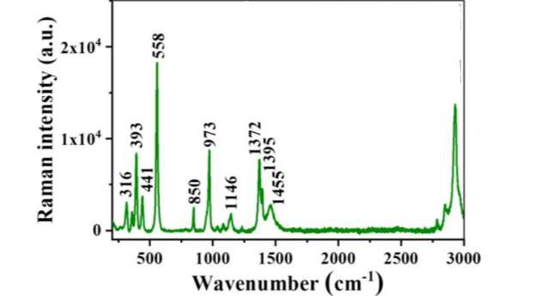

*Figure 49:DOI 10.1088/1361-6528/ab2845*

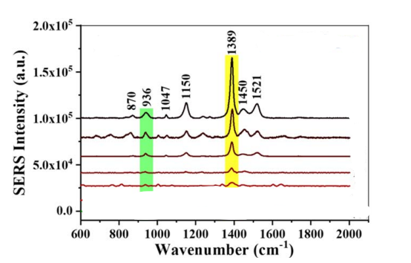

*Figure 50:DOI 10.1088/1361-6528/ab2845*

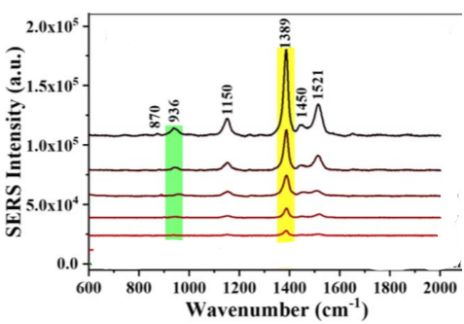

*Figure 51:DOI 10.1088/1361-6528/ab2845*

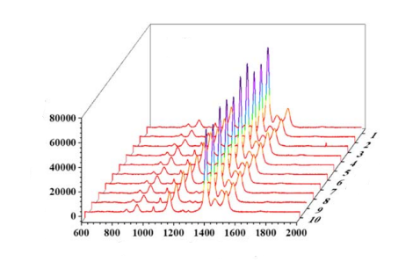

*Figure 52:DOI 10.1088/1361-6528/ab2845*

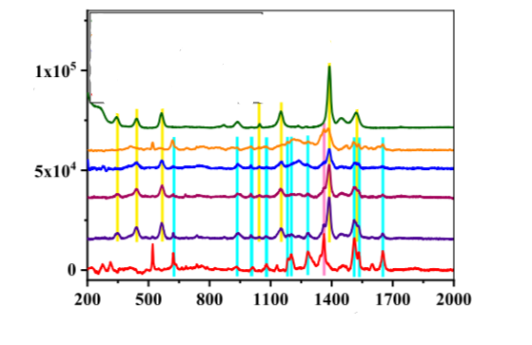

*Figure 53:DOI 10.1088/1361-6528/ab2845*

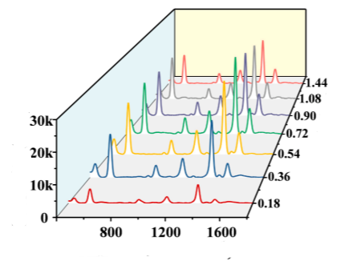

*Figure 54:https://doi.org/10.1016/j.saa.2025.125812*

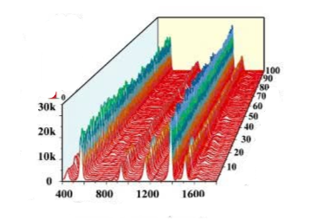

*Figure 55:https://doi.org/10.1016/j.saa.2025.125812*

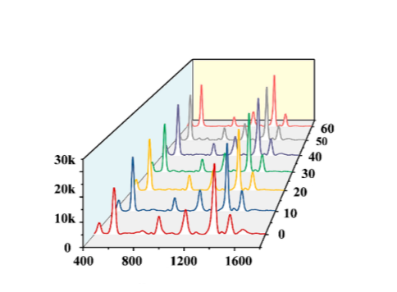

*Figure 56:https://doi.org/10.1016/j.saa.2025.125812*

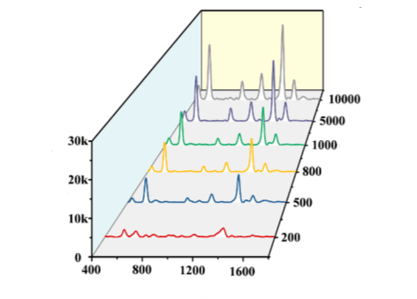

*Figure 57:https://doi.org/10.1016/j.saa.2025.125812*

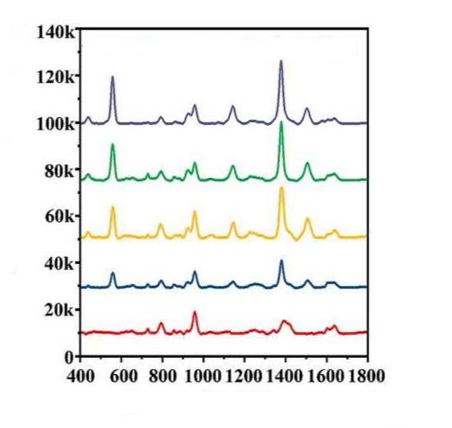

*Figure 58:https://doi.org/10.1016/j.saa.2025.125812*

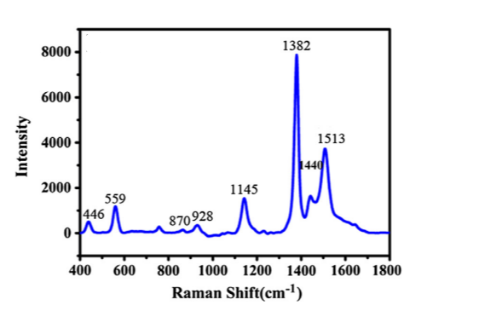

*Figure 59:https://doi.org/10.1016/j.saa.2013.10.013*

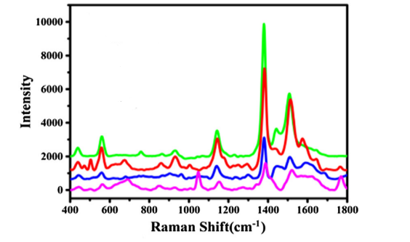

*Figure 60:https://doi.org/10.1016/j.saa.2013.10.013*

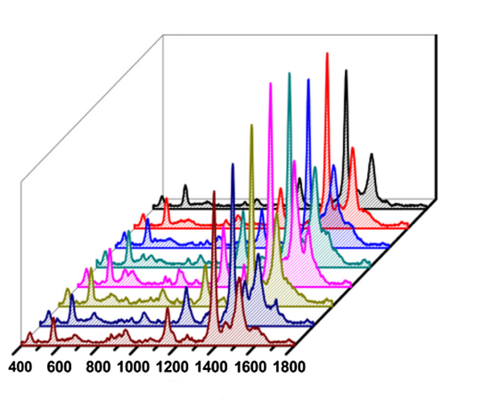

*Figure 61:https://doi.org/10.1016/j.saa.2013.10.013*

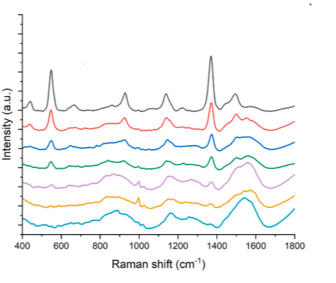

*Figure 62:https://doi.org/10.1016/j.talanta.2022.124128*

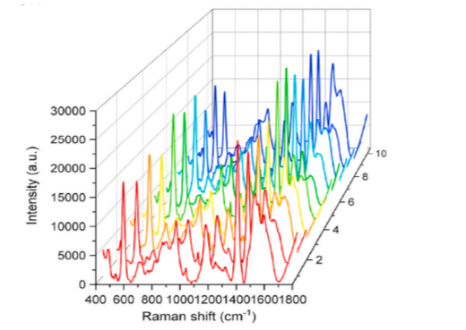

*Figure 63:https://doi.org/10.1016/j.talanta.2022.124128*

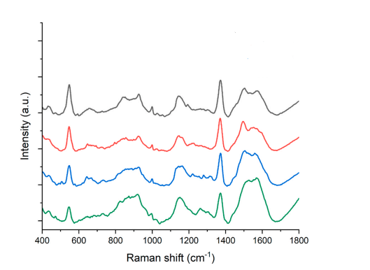

*Figure 64:https://doi.org/10.1016/j.talanta.2022.124128*

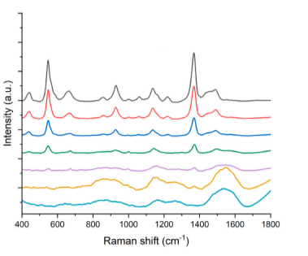

*Figure 65:https://doi.org/10.1016/j.talanta.2022.124128*

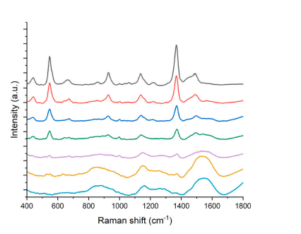

*Figure 66:https://doi.org/10.1016/j.talanta.2022.124128*

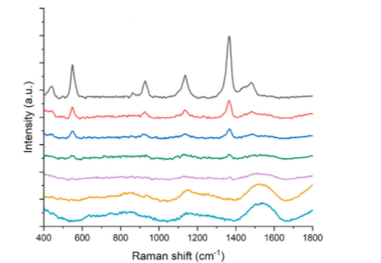

*Figure 67:https://doi.org/10.1016/j.talanta.2022.124128*

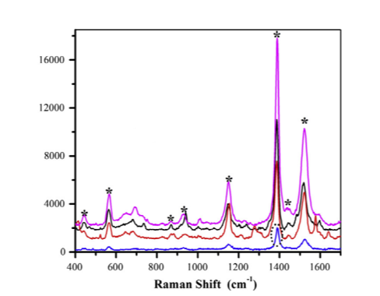

*Figure 68:https://doi.org/10.1016/j.saa.2014.06.054*

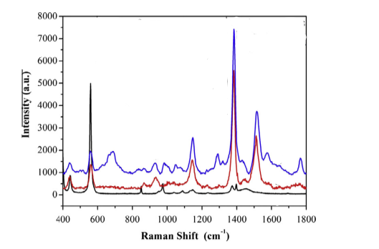

*Figure 69:https://doi.org/10.1016/j.saa.2014.06.054*

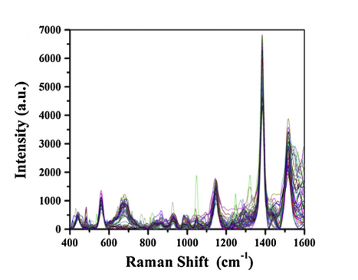

*Figure 70:https://doi.org/10.1016/j.saa.2014.06.054*

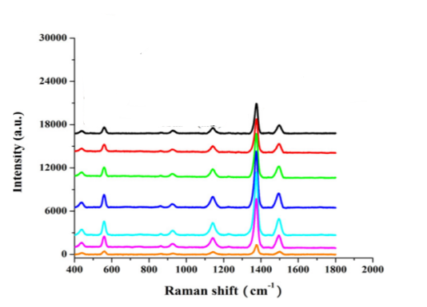

*Figure 71:https://doi.org/10.1016/j.saa.2017.08.074*

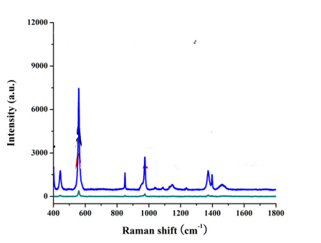

*Figure 72:https://doi.org/10.1016/j.saa.2017.08.074*

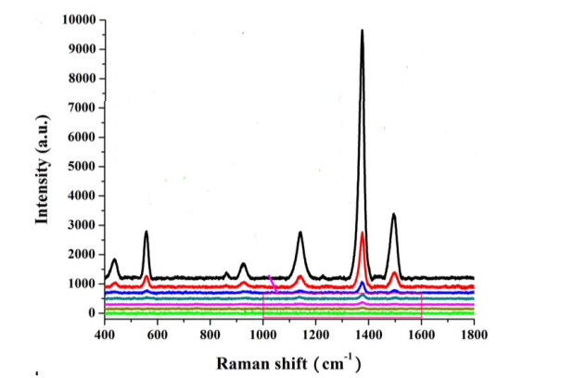

*Figure 73:https://doi.org/10.1016/j.saa.2017.08.074*

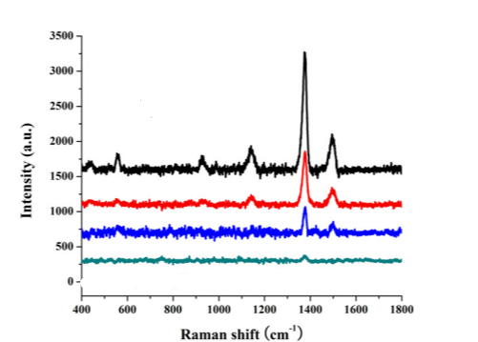

*Figure 74:https://doi.org/10.1016/j.saa.2017.08.074*

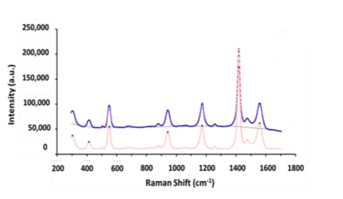

*Figure 75:https://doi.org/10.1016/j.apsusc.2021.149740*

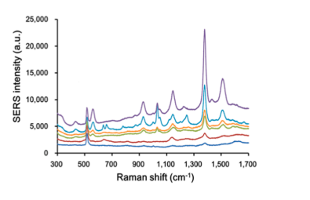

*Figure 76:https://doi.org/10.1016/j.apsusc.2021.149740*

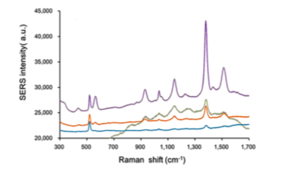

*Figure 77:https://doi.org/10.1016/j.apsusc.2021.149740*

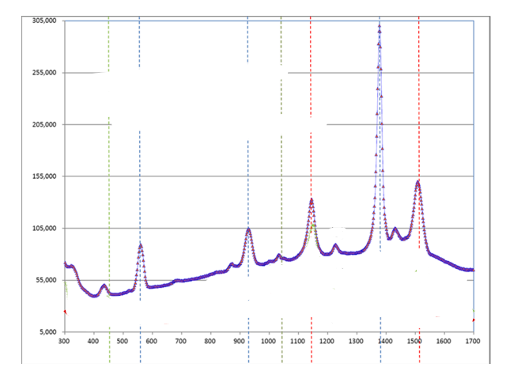

*Figure 78:https://doi.org/10.1016/j.apsusc.2021.149740*

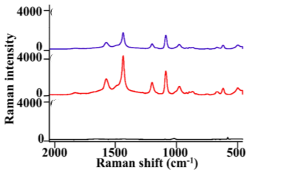

*Figure 79:https://doi.org/10.1016/j.saa.2022.122073*

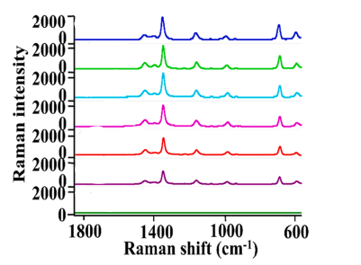

*Figure 80:https://doi.org/10.1016/j.saa.2022.122073*

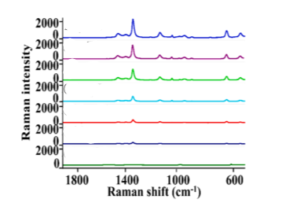

*Figure 81:https://doi.org/10.1016/j.saa.2022.122073*

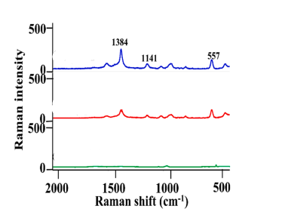

*Figure 82:https://doi.org/10.1016/j.saa.2022.122073*

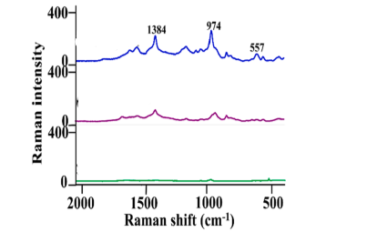

*Figure 83:https://doi.org/10.1016/j.saa.2022.122073*

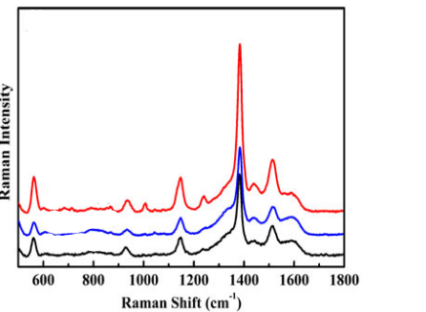

*Figure 84:https://doi.org/10.1080/00032719.2019.1691220*

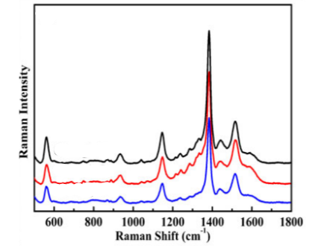

*Figure 85:https://doi.org/10.1080/00032719.2019.1691220*

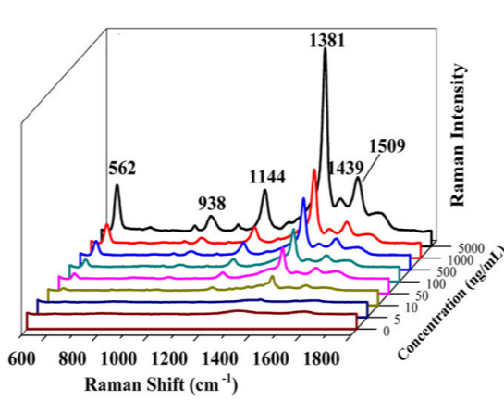

*Figure 86:https://doi.org/10.1080/00032719.2019.1691220*

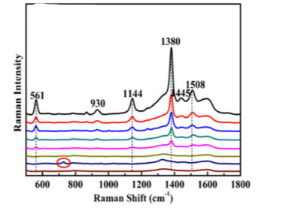

*Figure 87:https://doi.org/10.1080/00032719.2019.1691220*

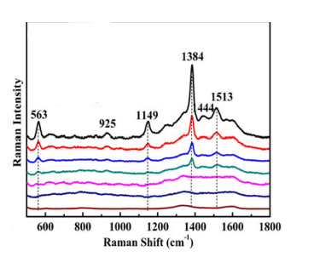

*Figure 88:https://doi.org/10.1080/00032719.2019.1691220*

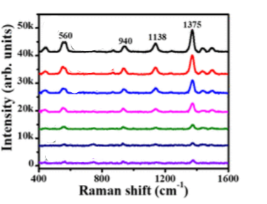

*Figure 89:https://doi.org/10.1021/acsomega.2c01095*

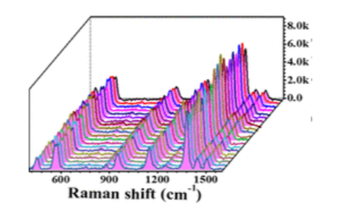

*Figure 90:https://doi.org/10.1021/acsomega.2c01095*

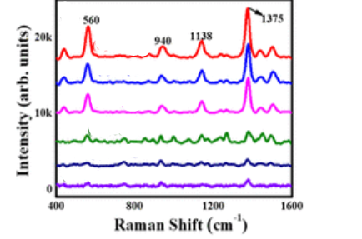

*Figure 91:https://doi.org/10.1021/acsomega.2c01095*

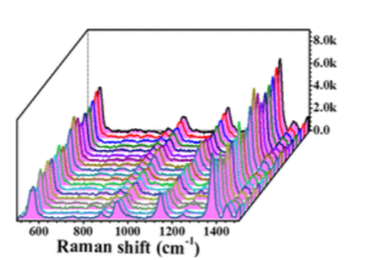

*Figure 92:https://doi.org/10.1021/acsomega.2c01095*

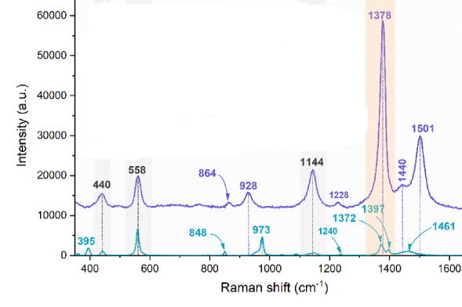

*Figure 93:https://doi.org/10.1016/j.saa.2024.123907*

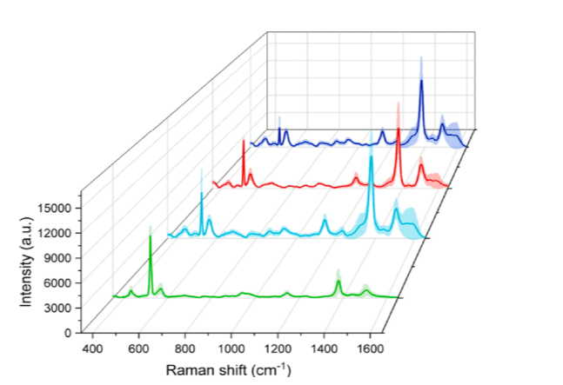

*Figure 94:https://doi.org/10.1016/j.saa.2024.123907*

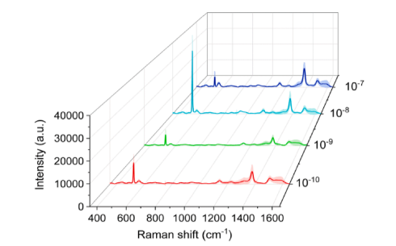

*Figure 95:https://doi.org/10.1016/j.saa.2024.123907*

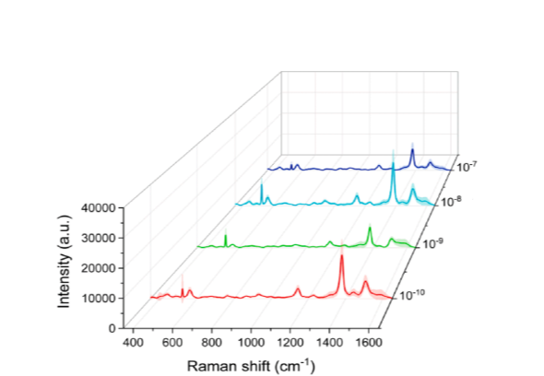

*Figure 96:https://doi.org/10.1016/j.saa.2024.123907*

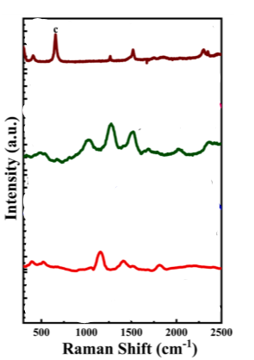

*Figure 97:https://doi.org/10.1016/j.sna.2023.114341*

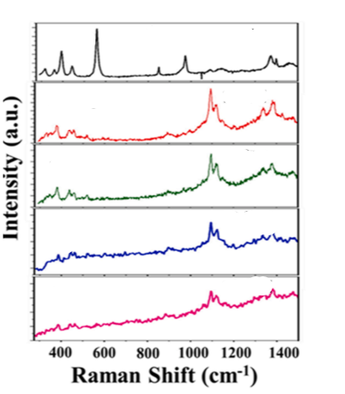

*Figure 98:https://doi.org/10.1016/j.sna.2023.114341*

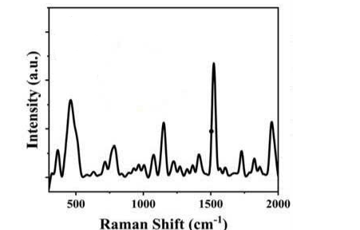

*Figure 99:https://doi.org/10.1016/j.sna.2023.114341*

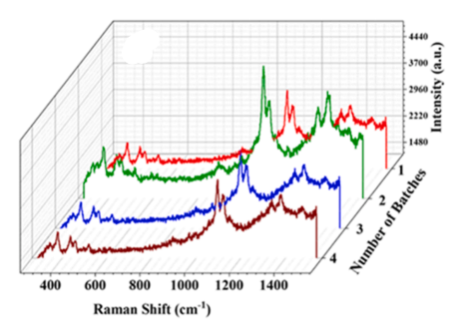

*Figure 100:https://doi.org/10.1016/j.sna.2023.114341*

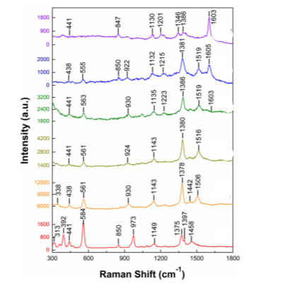

*Figure 101:https://doi.org/10.1007/s10876-021-02197-z*

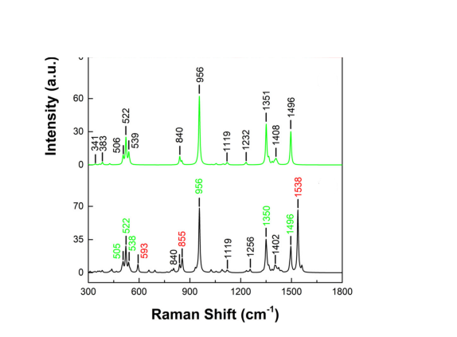

*Figure 102:https://doi.org/10.1007/s10876-021-02197-z*

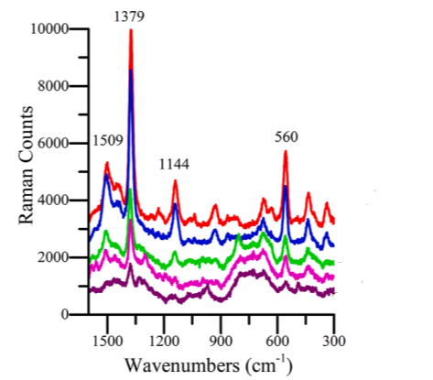

*Figure 103:https://doi.org/10.1016/j.foodchem.2021.131570*

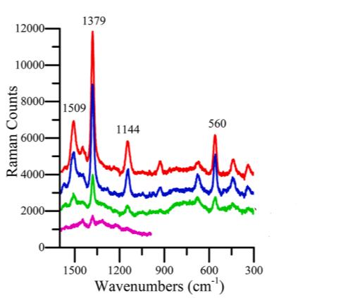

*Figure 104:https://doi.org/10.1016/j.foodchem.2021.131570*

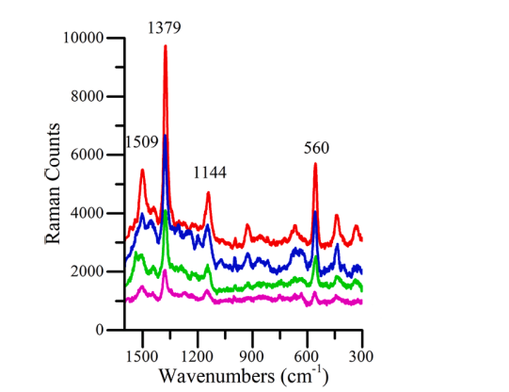

*Figure 105:*[*https://doi.org/10.1016/j.foodchem.2021.131570*](https://doi.org/10.1016/j.foodchem.2021.131570)

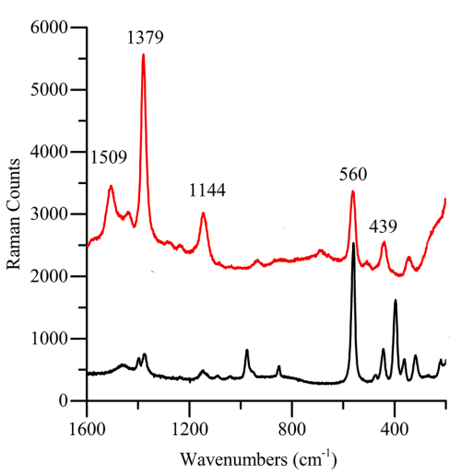

*Figure 106:*[*https://doi.org/10.1016/j.foodchem.2021.131570*](https://doi.org/10.1016/j.foodchem.2021.131570)

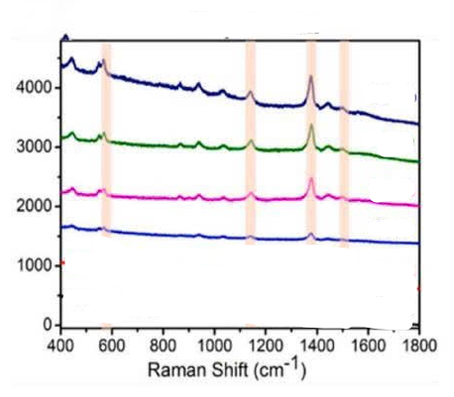

*Figure 107: https://doi.org/10.1016/j.foodchem.2024.140486*

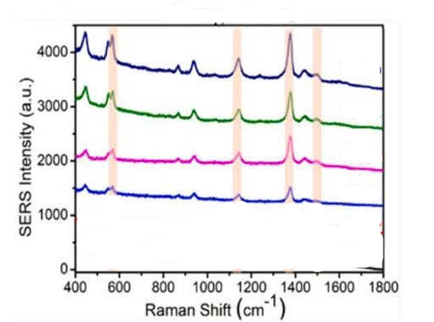

*Figure 108:https://doi.org/10.1016/j.foodchem.2024.140486*

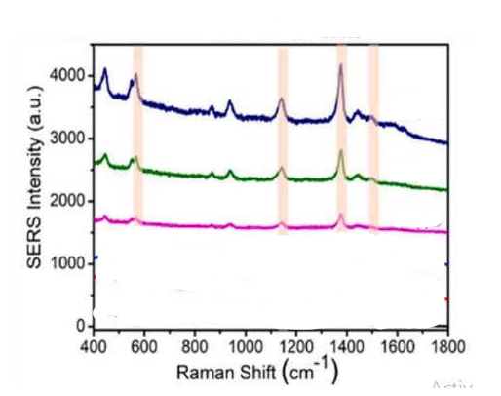

*Figure 109:https://doi.org/10.1016/j.foodchem.2024.140486*

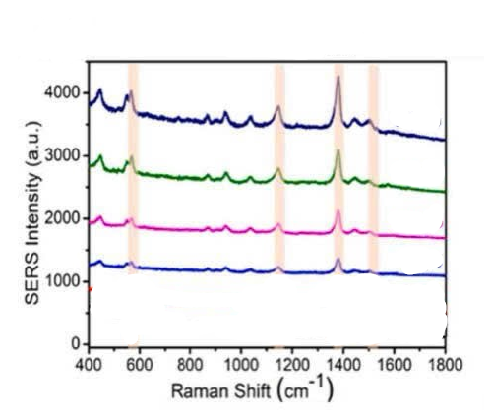

*Figure 110:*[*https://doi.org/10.1016/j.foodchem.2024.140486*](https://doi.org/10.1016/j.foodchem.2024.140486)

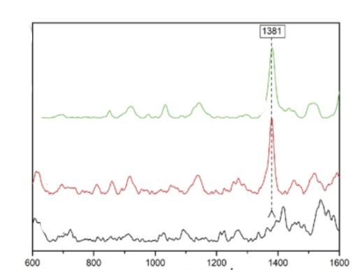

*Figure 111:* [*https://doi.org/10.3390/bios9030111*](https://doi.org/10.3390/bios9030111)

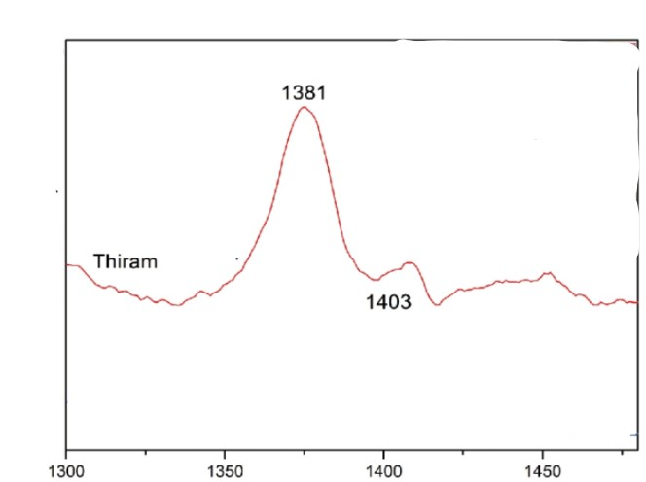

*Figure 112:* [*https://doi.org/10.3390/bios9030111*](https://doi.org/10.3390/bios9030111)

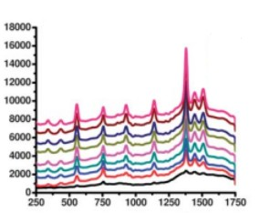

*Fig 113:* [***https://doi.org/10.1039/C0AN00594K***](https://doi.org/10.1039/C0AN00594K)

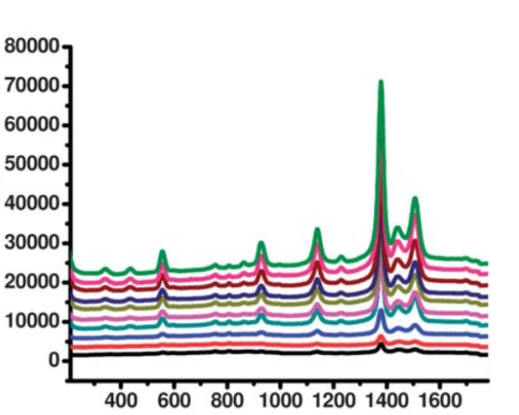

*Figure 114:* [***https://doi.org/10.1039/C0AN00594K***](https://doi.org/10.1039/C0AN00594K)

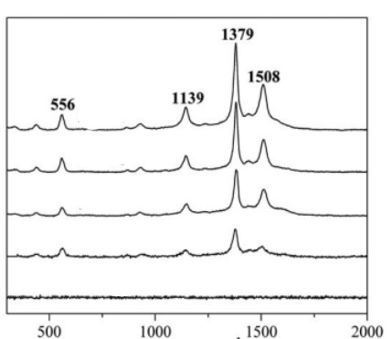

*Fig 115:* [*https://doi.org/10.1039/C1JM12919H*](https://doi.org/10.1039/C1JM12919H)

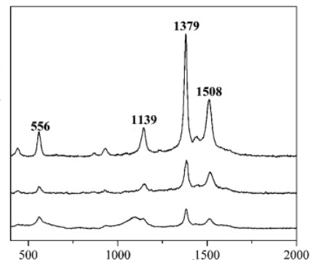

*Fig 116:* [*https://doi.org/10.1039/C1JM12919H*](https://doi.org/10.1039/C1JM12919H)

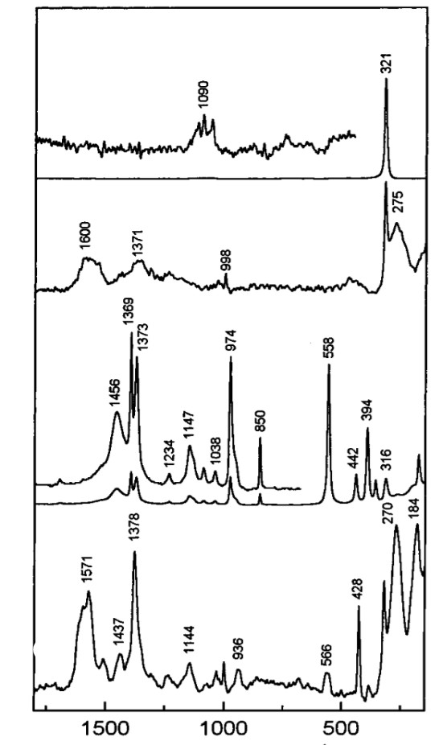

*Fig 117:* [*https://doi.org/10.1021/la001269z*](https://doi.org/10.1021/la001269z)

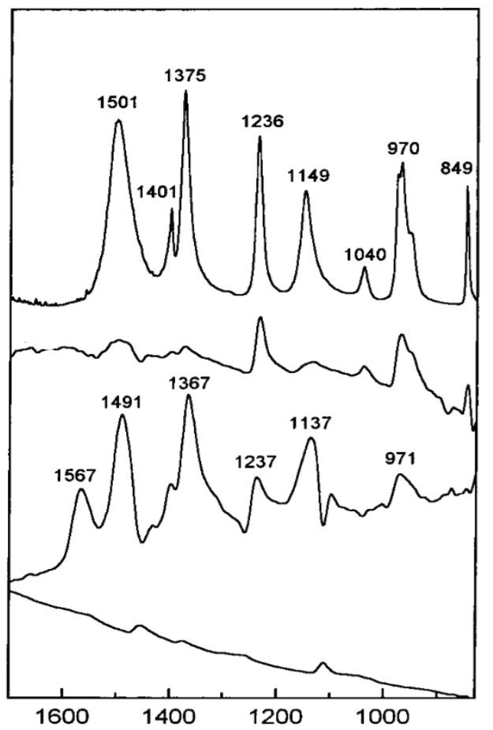

*Fig 118:* [*https://doi.org/10.1021/la001269z*](https://doi.org/10.1021/la001269z)

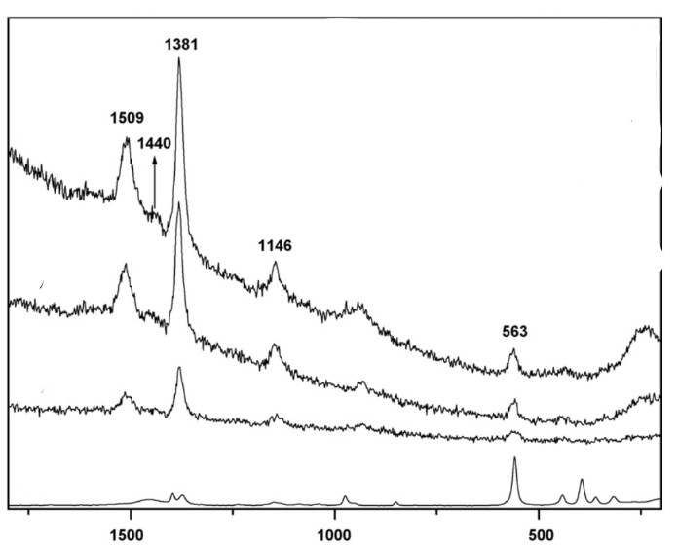

*Fig 119:* [*https://doi.org/10.1016/j.colsurfa.2009.01.018*](https://doi.org/10.1016/j.colsurfa.2009.01.018)

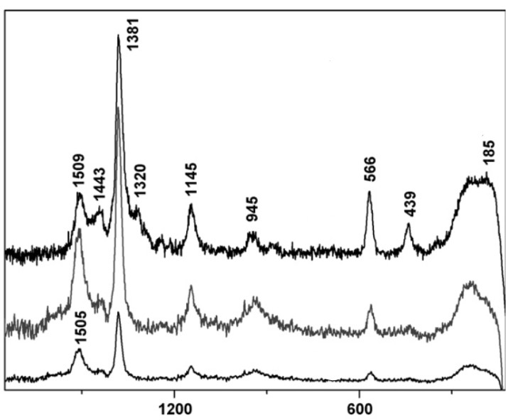

*Figure 120:* [*https://doi.org/10.1016/j.colsurfa.2009.01.018*](https://doi.org/10.1016/j.colsurfa.2009.01.018)

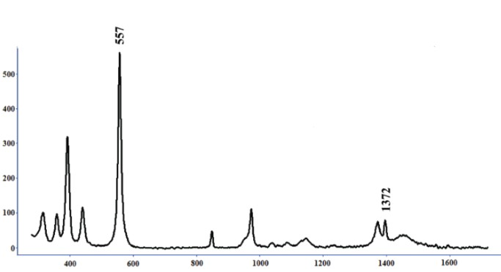

Figure 121:[**https://doi.org/10.1039/C9AN00687G**](https://doi.org/10.1039/C9AN00687G)

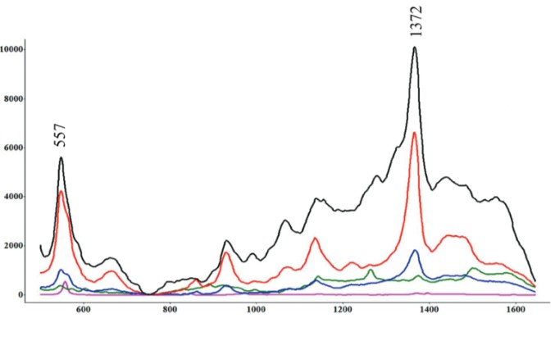

Figure 122:[**https://doi.org/10.1039/C9AN00687G**](https://doi.org/10.1039/C9AN00687G)

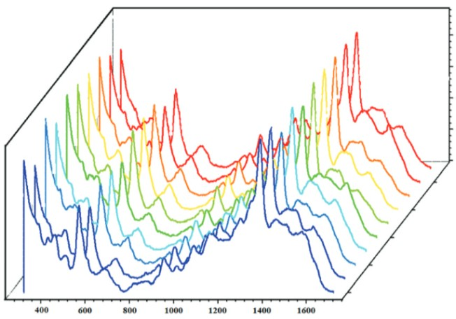

Figure 123:[**https://doi.org/10.1039/C9AN00687G**](https://doi.org/10.1039/C9AN00687G)

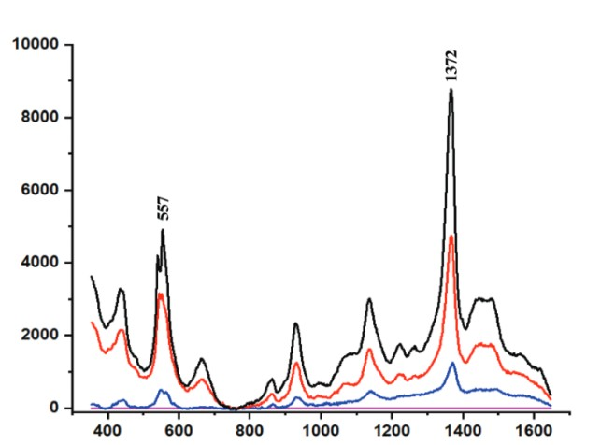

Figure 124:[**https://doi.org/10.1039/C9AN00687G**](https://doi.org/10.1039/C9AN00687G)

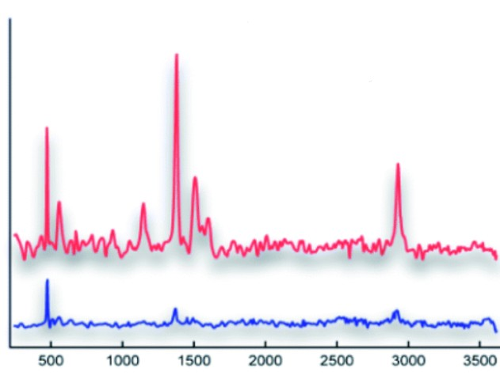

Figure 125:**10.1039/D2RA03396H**

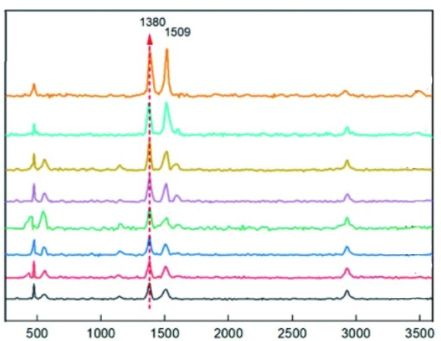

Figure 126 : **10.1039/D2RA03396H**

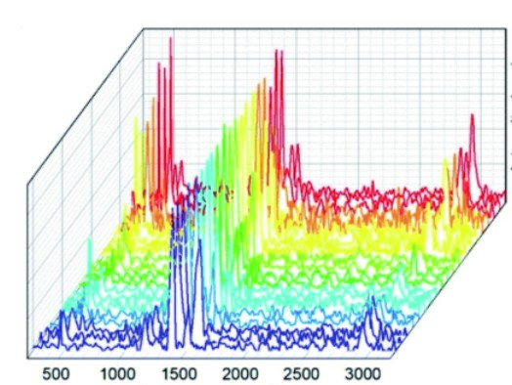

Figure 127 : **10.1039/D2RA03396H**

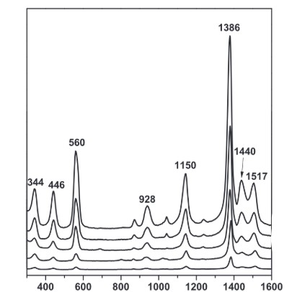

Figure 128 : 10.1088/2043-6254/ab2245

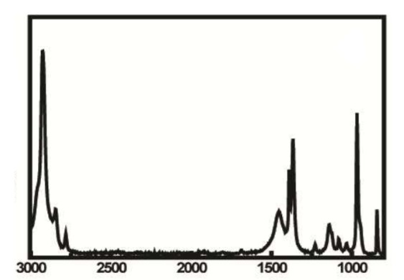

Figure 129 : <https://doi.org/10.1021/acsanm.8b01104>

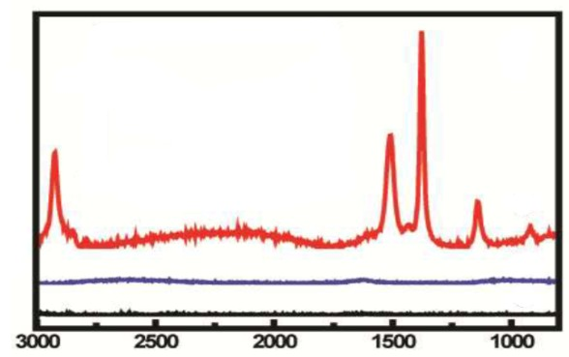

Figure 130 : <https://doi.org/10.1021/acsanm.8b01104>

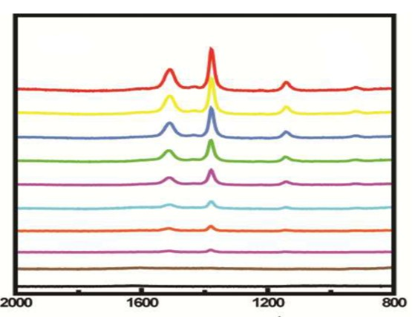

Figure 131 : <https://doi.org/10.1021/acsanm.8b01104>

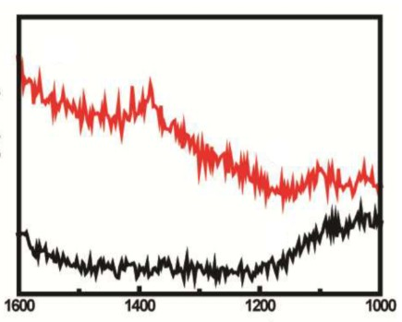

Figure 132 : <https://doi.org/10.1021/acsanm.8b01104>

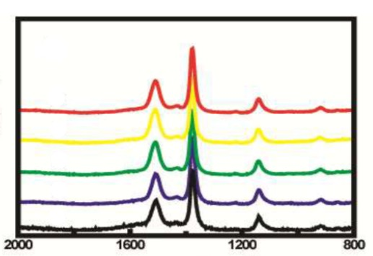

Figure 133 : <https://doi.org/10.1021/acsanm.8b01104>

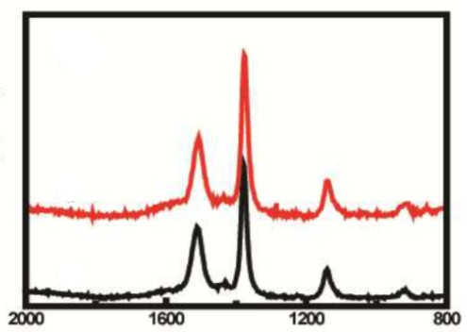

Figure 134 : <https://doi.org/10.1021/acsanm.8b01104>

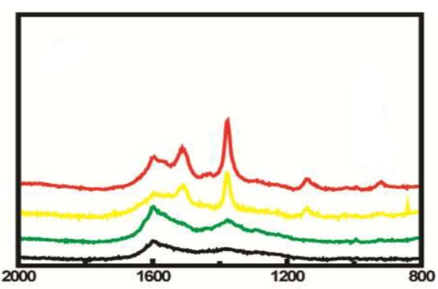

Figure 135 : <https://doi.org/10.1021/acsanm.8b01104>

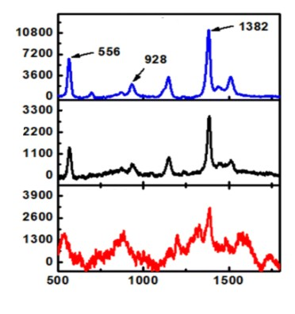

Figure 136 : [10.1039/D4RA00048J](https://doi.org/10.1039/D4RA00048J)

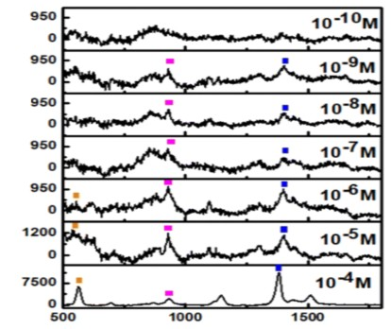

Figure 137 : [10.1039/D4RA00048J](https://doi.org/10.1039/D4RA00048J)

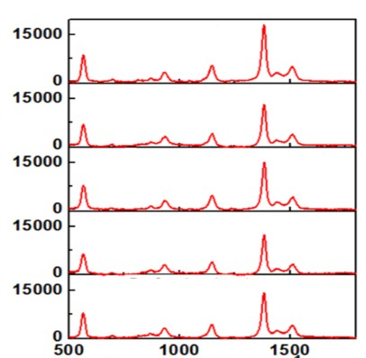

Figure 138 : [10.1039/D4RA00048J](https://doi.org/10.1039/D4RA00048J)

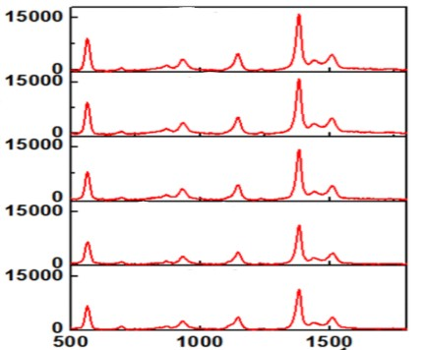

Figure 139 : [10.1039/D4RA00048J](https://doi.org/10.1039/D4RA00048J)

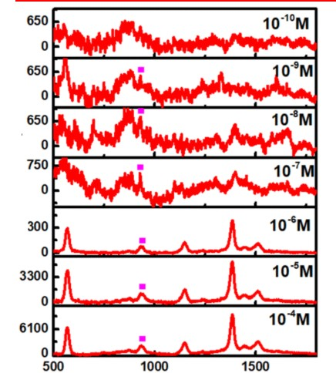

Figure 140 : [10.1039/D4RA00048J](https://doi.org/10.1039/D4RA00048J)

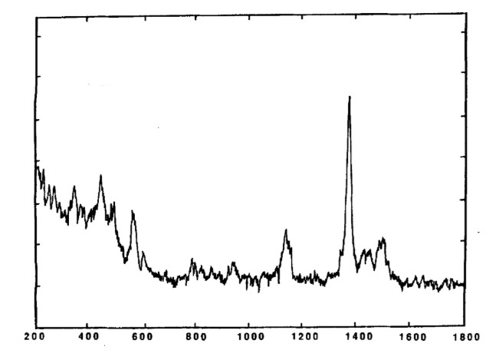

Figure 141 : <https://doi.org/10.1002/jrs.1250230507>

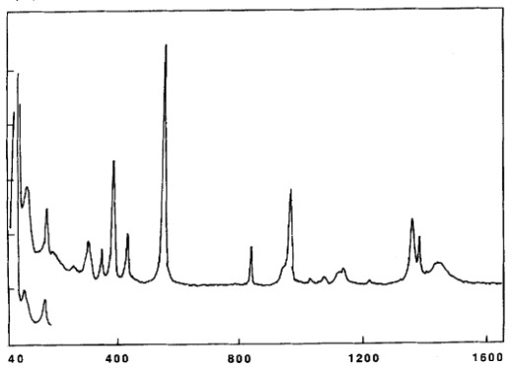

Figure 142 : <https://doi.org/10.1002/jrs.1250230507>

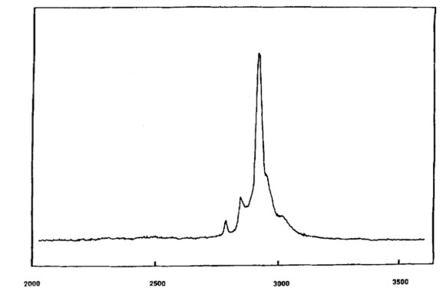

Figure 143 : <https://doi.org/10.1002/jrs.1250230507>

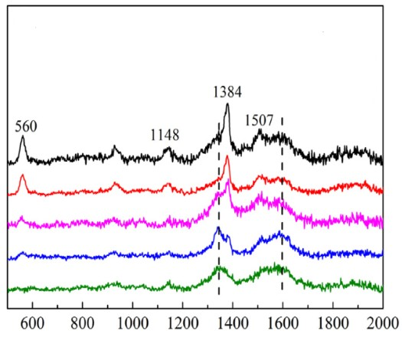

Figure 144 : <https://doi.org/10.1016/j.apsusc.2017.04.159>

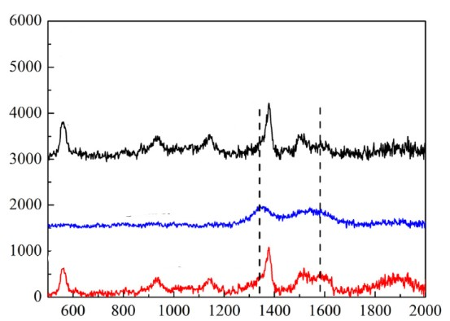

Figure 145 : <https://doi.org/10.1016/j.apsusc.2017.04.159>

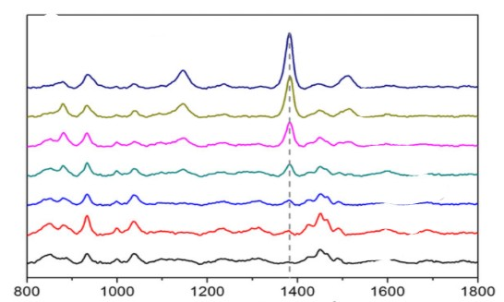

Figure 146 : <https://doi.org/10.1002/jrs.5595>

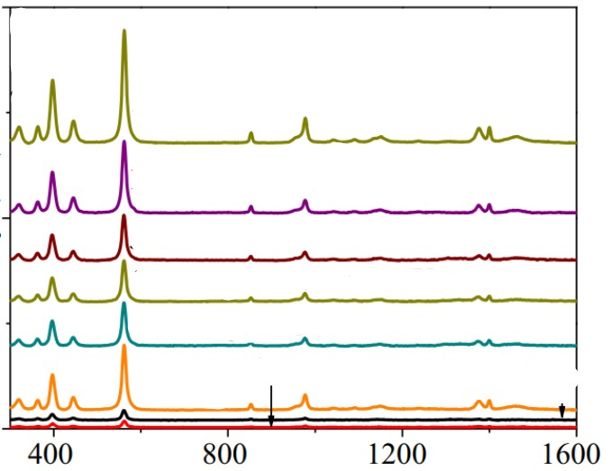

Figure 147: <https://doi.org/10.1007/s11696-023-03276-3>

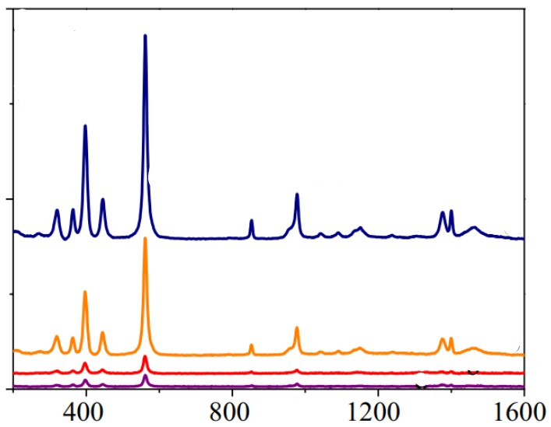

Figure 148: <https://doi.org/10.1007/s11696-023-03276-3>

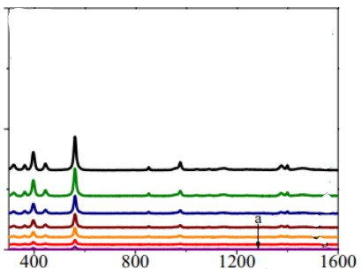

Figure 149 : <https://doi.org/10.1007/s11696-023-03276-3>

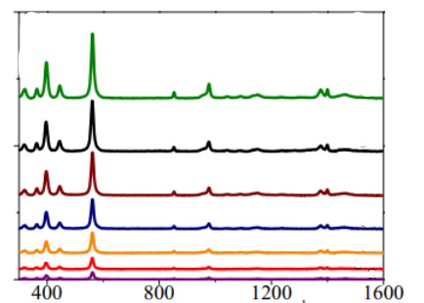

Figure 150 : <https://doi.org/10.1007/s11696-023-03276-3>

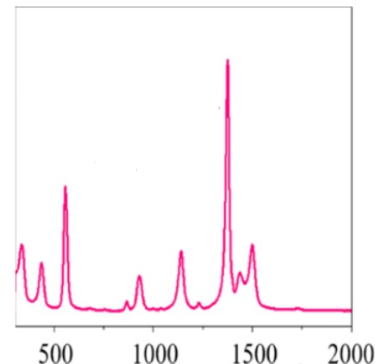

Figure 151 : <https://doi.org/10.1021/acsanm.4c06045>

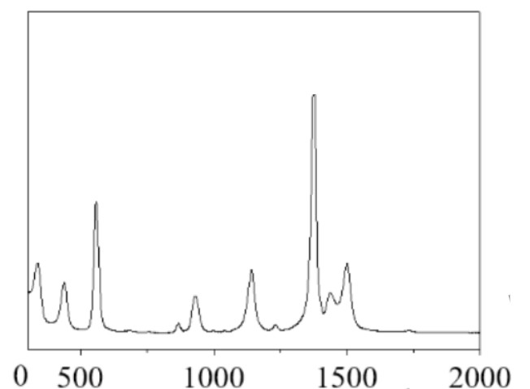

Figure 152: [**https://doi.org/10.1021/acsanm.4c06045**](https://doi.org/10.1021/acsanm.4c06045)

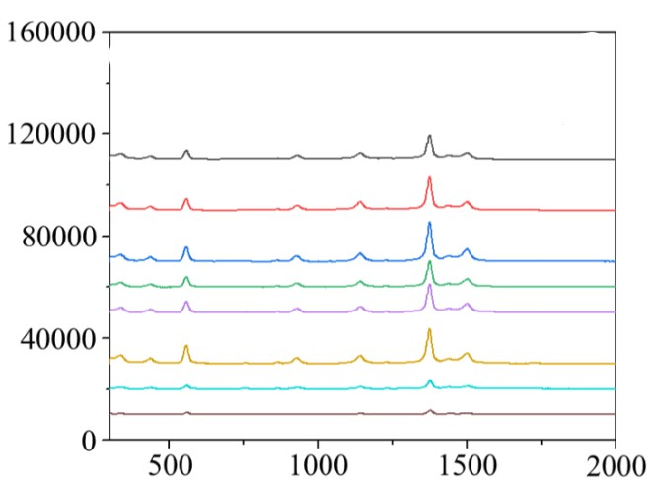

Figure 153:<https://doi.org/10.1021/acsanm.4c06045>

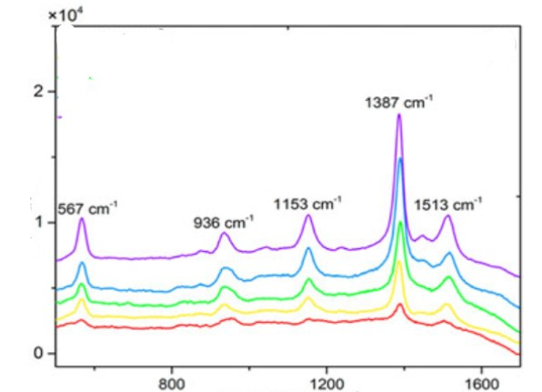

Figure 154 : <https://doi.org/10.1080/00032719.2019.1687509>

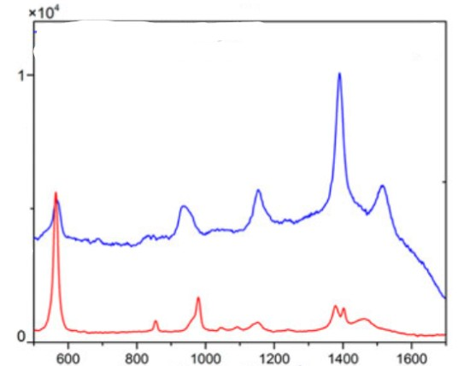

Figure 155 : <https://doi.org/10.1080/00032719.2019.1687509>

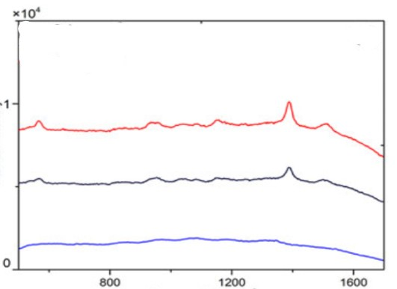

Figure 156 : <https://doi.org/10.1080/00032719.2019.1687509>

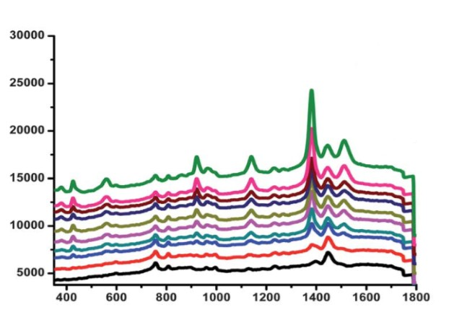

Figure 157 : [**https://doi.org/10.1039/C2AN36047K**](https://doi.org/10.1039/C2AN36047K)

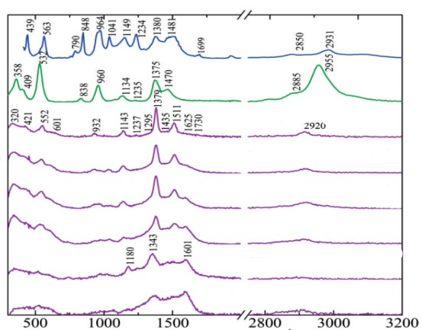

Figure 158 : <https://doi.org/10.1177/0003702816652356>

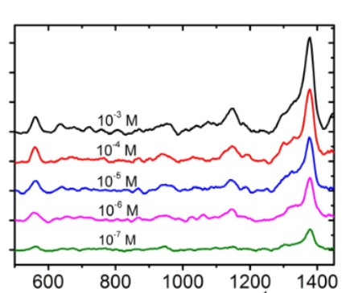

Figure 159 : [**https://doi.org/10.3390/nano9091331**](https://doi.org/10.3390/nano9091331)

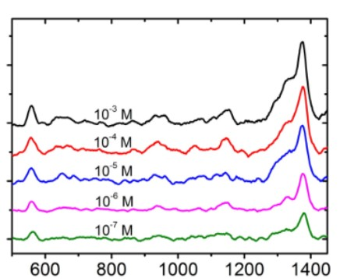

Figure 160 : [**https://doi.org/10.3390/nano9091331**](https://doi.org/10.3390/nano9091331)

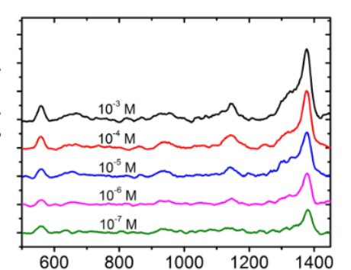

Figure 161 : [**https://doi.org/10.3390/nano9091331**](https://doi.org/10.3390/nano9091331)

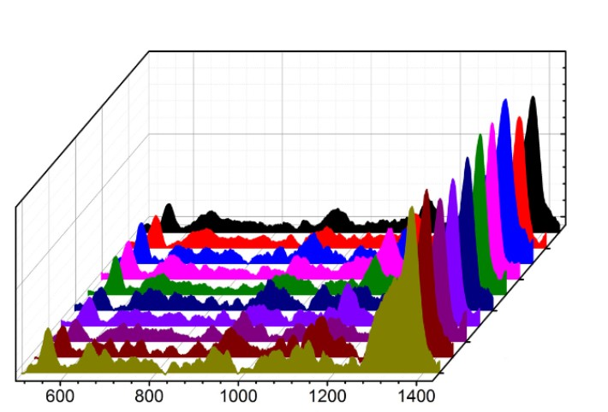

Figure 162 : [**https://doi.org/10.3390/nano9091331**](https://doi.org/10.3390/nano9091331)

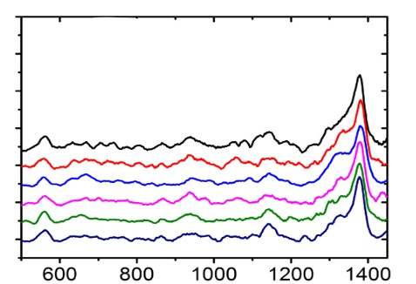

Figure 163 : [**https://doi.org/10.3390/nano9091331**](https://doi.org/10.3390/nano9091331)

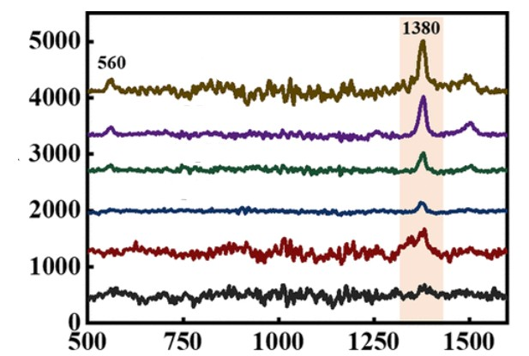

Figure 164 : <https://doi.org/10.1021/acs.jpcc.4c05112>

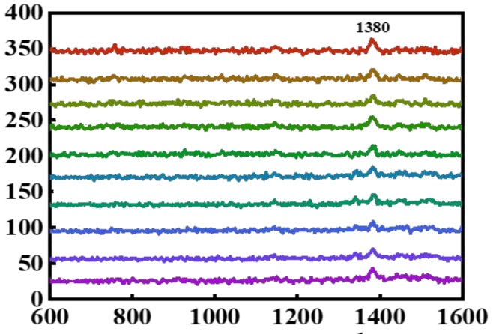

Figure 165: <https://doi.org/10.1021/acs.jpcc.4c05112>

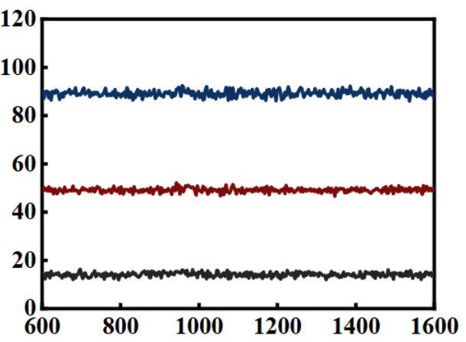

Figure 166: <https://doi.org/10.1021/acs.jpcc.4c05112>

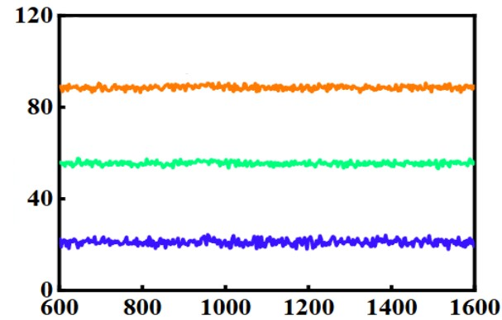

Figure 167: <https://doi.org/10.1021/acs.jpcc.4c05112>

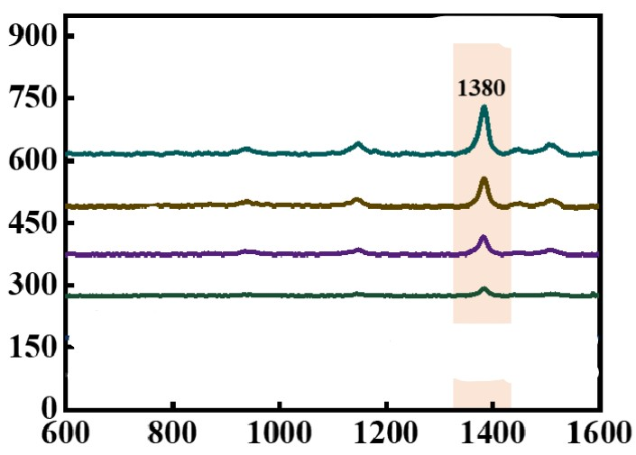

Figure 168: <https://doi.org/10.1021/acs.jpcc.4c05112>

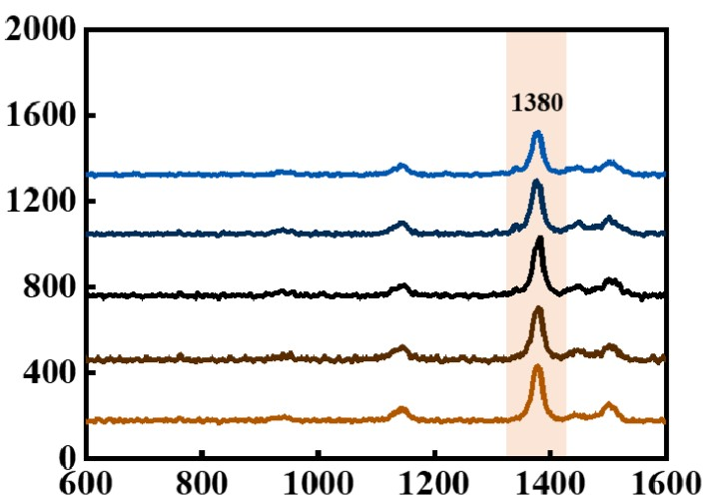

Figure 169: <https://doi.org/10.1021/acs.jpcc.4c05112>

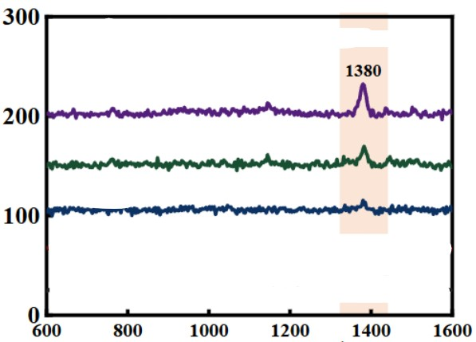

Figure 170: <https://doi.org/10.1021/acs.jpcc.4c05112>

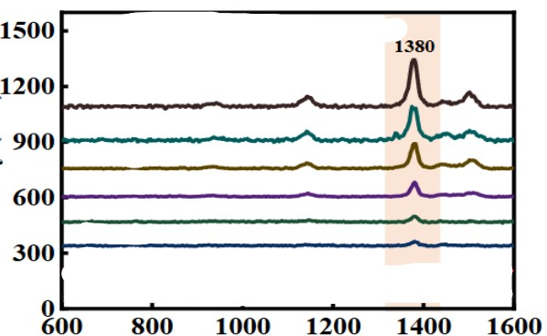

Figure 171: <https://doi.org/10.1021/acs.jpcc.4c05112>

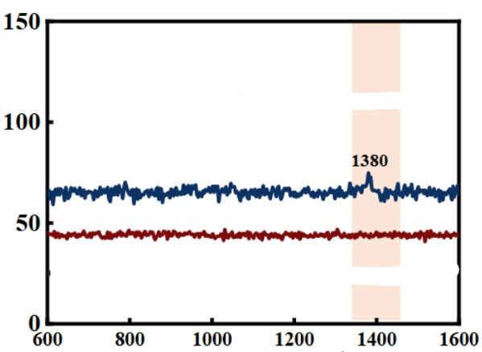

Figure 172: <https://doi.org/10.1021/acs.jpcc.4c05112>

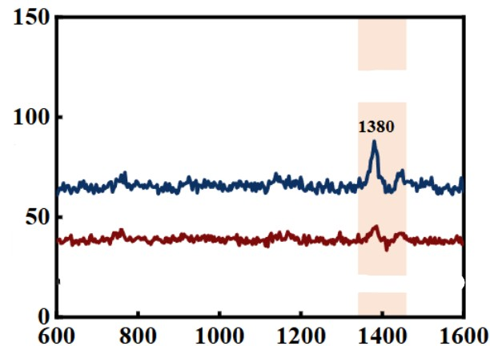

Figure 173: <https://doi.org/10.1021/acs.jpcc.4c05112>

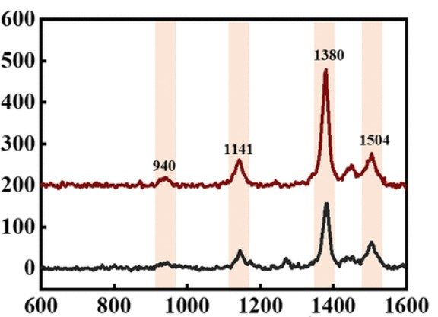

Figure 174 : <https://doi.org/10.1021/acs.jpcc.4c05112>

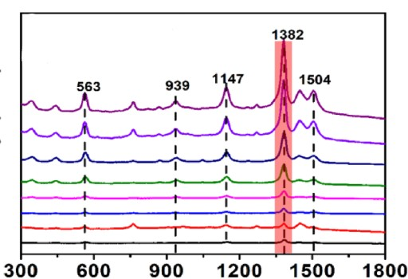

Figure 175 : <https://doi.org/10.1016/j.foodchem.2020.128570>

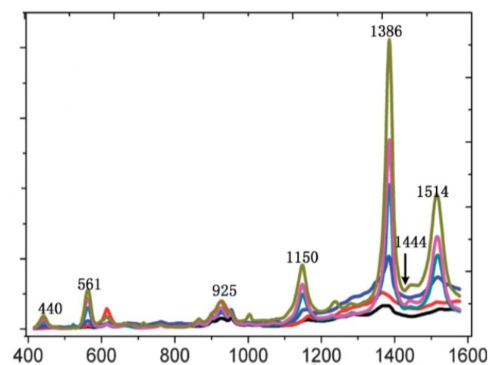

Figure 176 : <https://doi.org/10.1117/12.2267123>

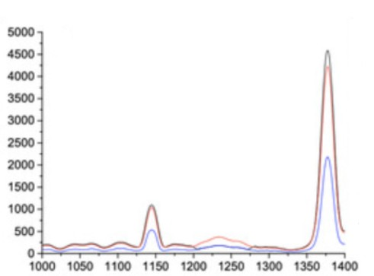

Figure 177 : [**https://doi.org/10.3390/nano11092174**](https://doi.org/10.3390/nano11092174)

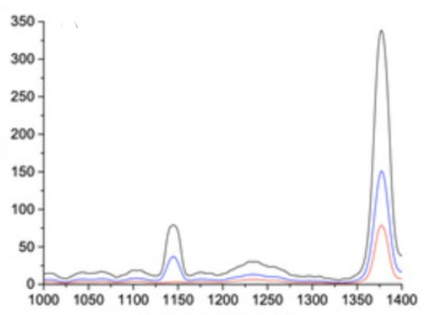

Figure 178 : [**https://doi.org/10.3390/nano11092174**](https://doi.org/10.3390/nano11092174)

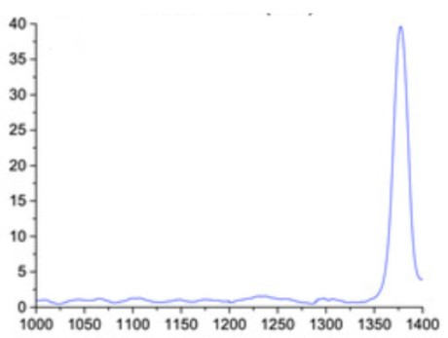

Figure 179 : [**https://doi.org/10.3390/nano11092174**](https://doi.org/10.3390/nano11092174)

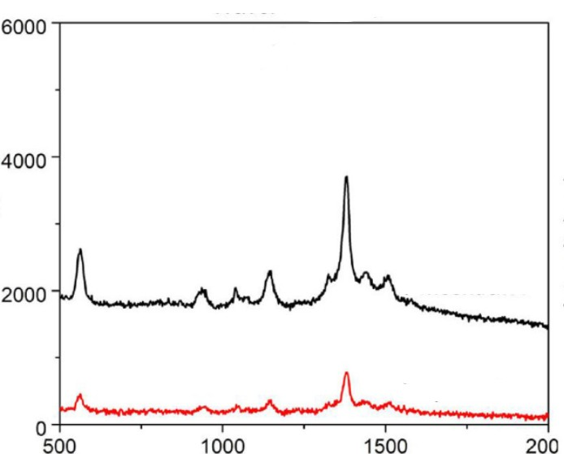

Figure 180 : <https://doi.org/10.1016/j.jhazmat.2020.122356>

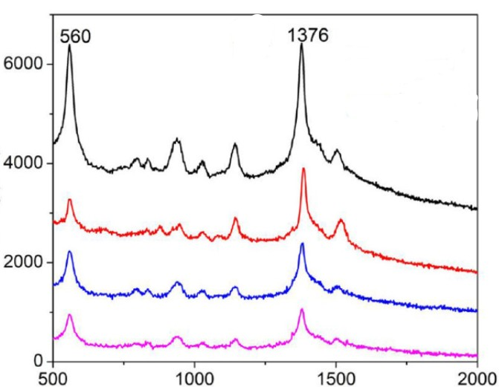

Figure 181 : <https://doi.org/10.1016/j.jhazmat.2020.122356>

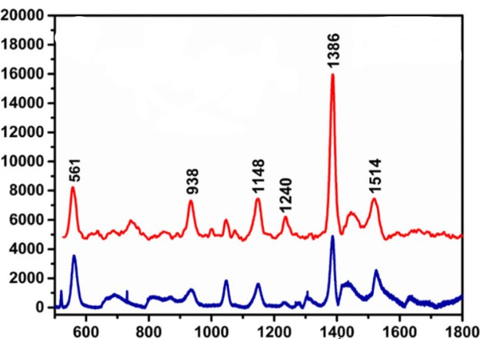

Figure 182 : <https://doi.org/10.1007/s11468-020-01172-0>

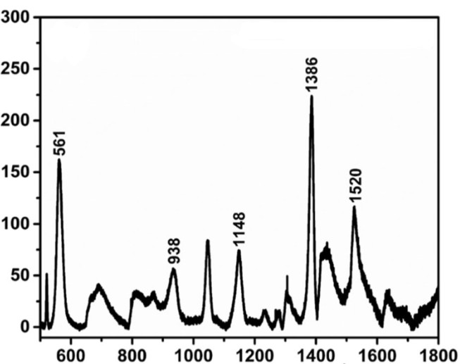

Figure 183 : <https://doi.org/10.1007/s11468-020-01172-0>

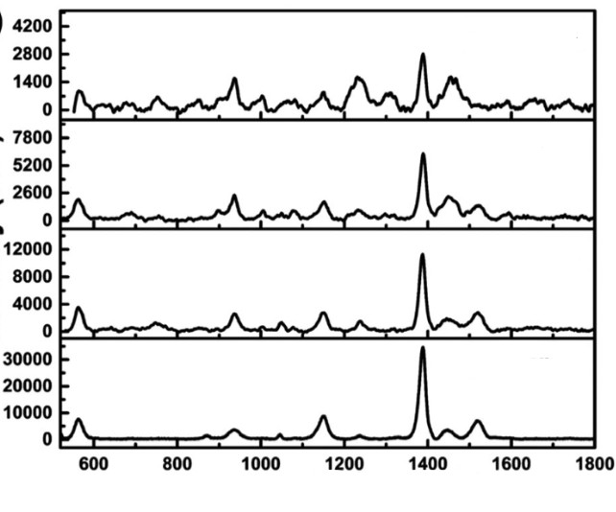

Figure 184 : <https://doi.org/10.1007/s11468-020-01172-0>

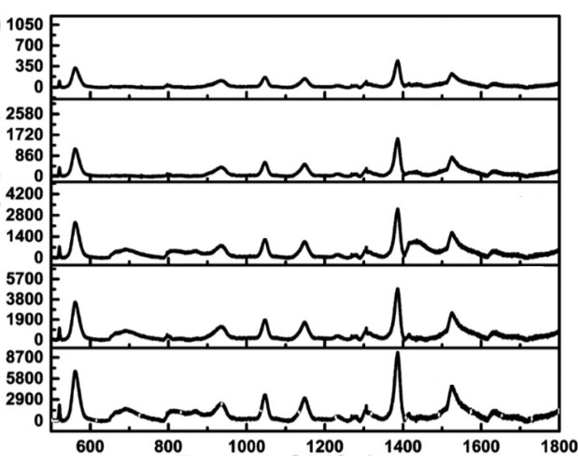

Figure 185 : <https://doi.org/10.1007/s11468-020-01172-0>

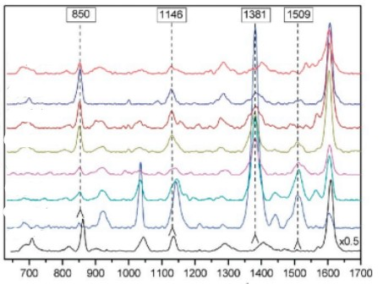

*Figure 186:* [*https://doi.org/10.3390/bios9030111*](https://doi.org/10.3390/bios9030111)

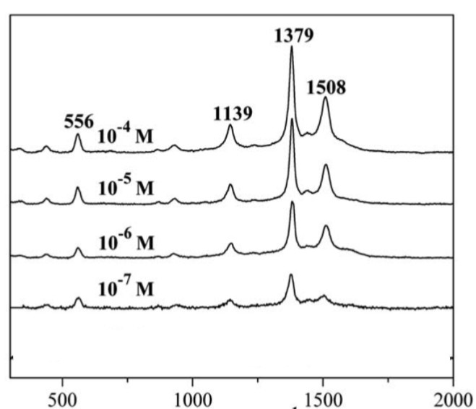

Figure 187:[**https://doi.org/10.1039/C1JM12919H**](https://doi.org/10.1039/C1JM12919H)

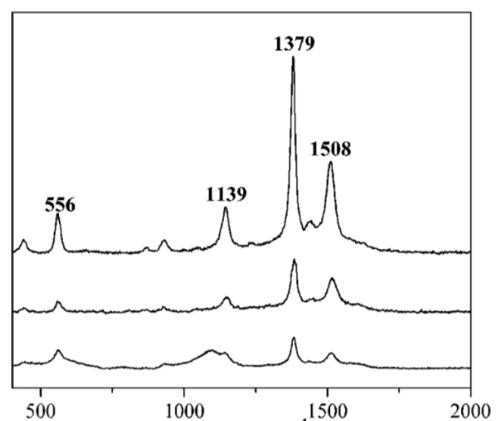

Figure 188: [**https://doi.org/10.1039/C1JM12919H**](https://doi.org/10.1039/C1JM12919H)

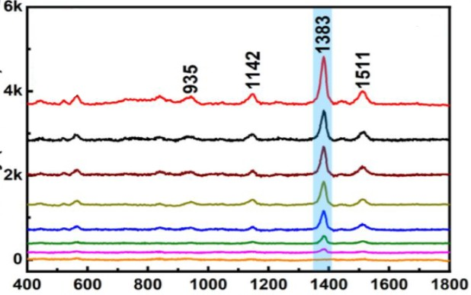

Figure 189: <https://doi.org/10.1021/acs.langmuir.2c02941>

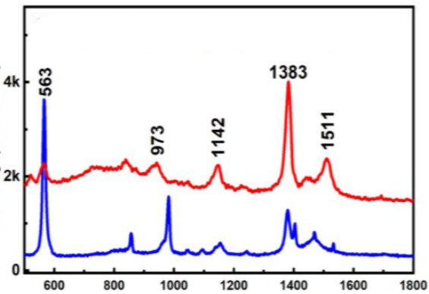

Figure 190: <https://doi.org/10.1021/acs.langmuir.2c02941>

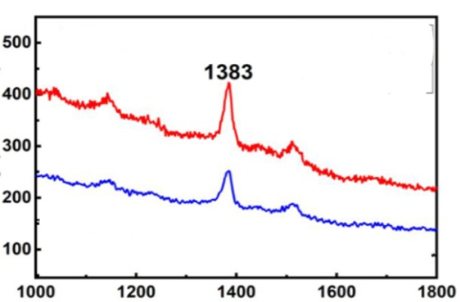

Figure 191: <https://doi.org/10.1021/acs.langmuir.2c02941>

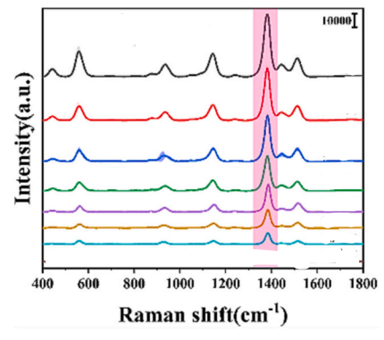

Figure 192 : <https://doi.org/10.1016/j.ijbiomac.2024.129941>

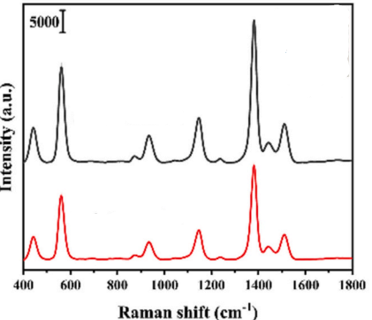

Figure 193 : <https://doi.org/10.1016/j.ijbiomac.2024.129941>

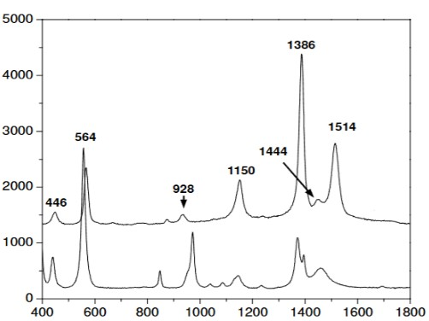

Figure 194: <https://doi.org/10.1021/ac202452t>

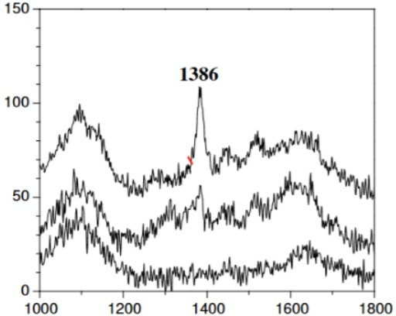

Figure 195: <https://doi.org/10.1021/ac202452t>

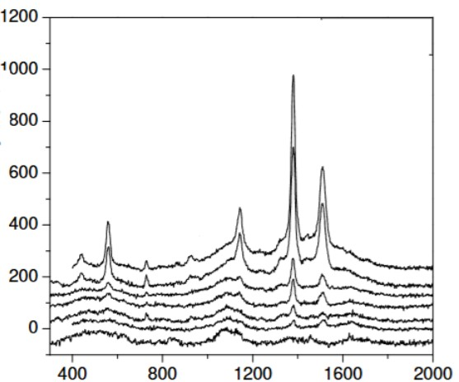

Figure 196: <https://doi.org/10.1021/ac202452t>

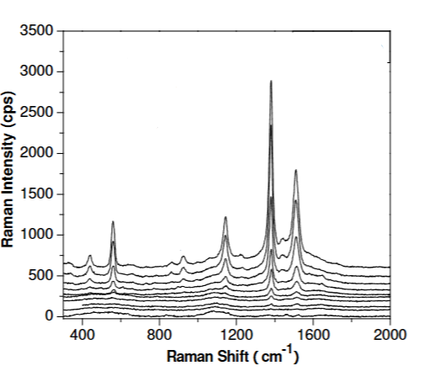

Figure 197: <https://doi.org/10.1021/ac202452t>

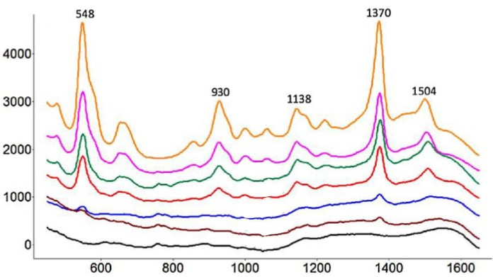

Figure 198: <https://doi.org/10.1016/j.carbpol.2018.02.014>

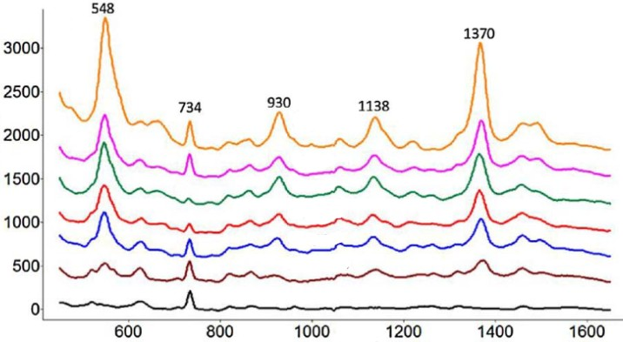

Figure 199: <https://doi.org/10.1016/j.carbpol.2018.02.014>

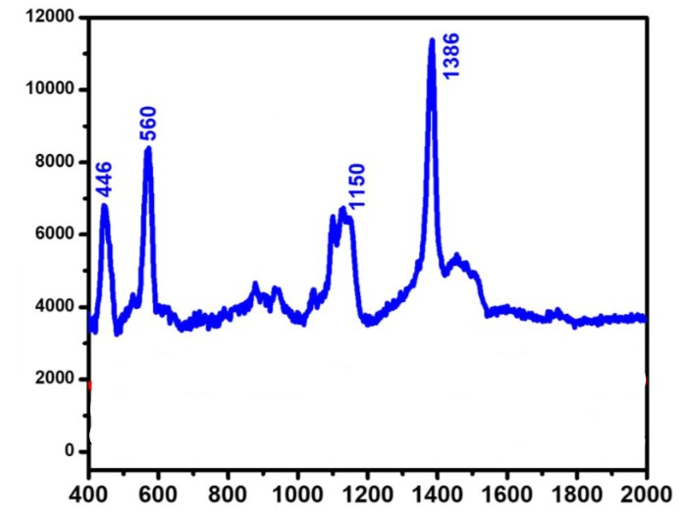

Figure 200: 10.1039/d4ra07061e

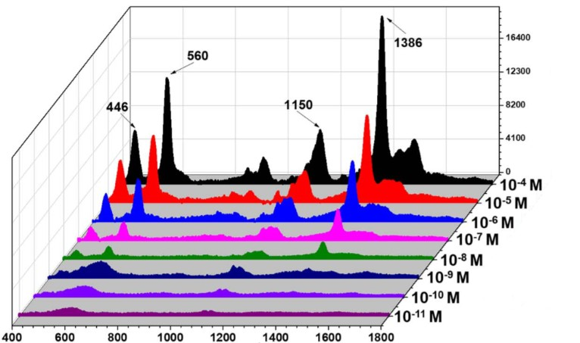

Figure 201: 10.1039/d4ra07061e

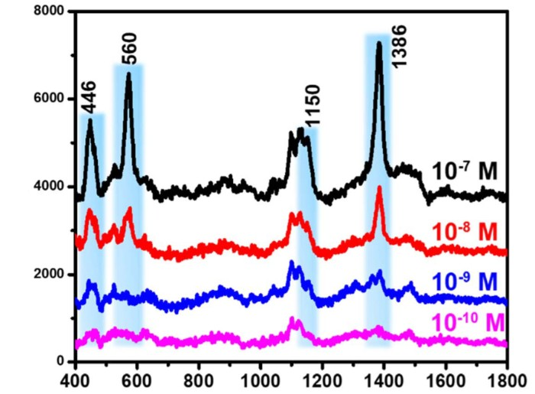

Figure 202: 10.1039/d4ra07061e

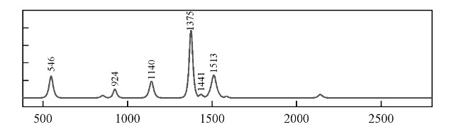

Figure 203: <https://doi.org/10.56028/aetr.2.1.104>

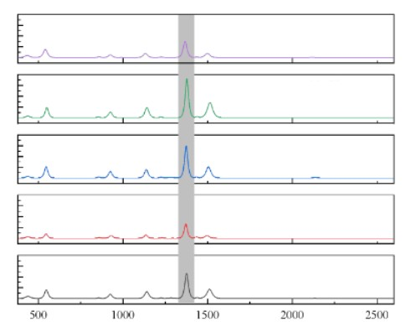

Figure 204: <https://doi.org/10.56028/aetr.2.1.104>

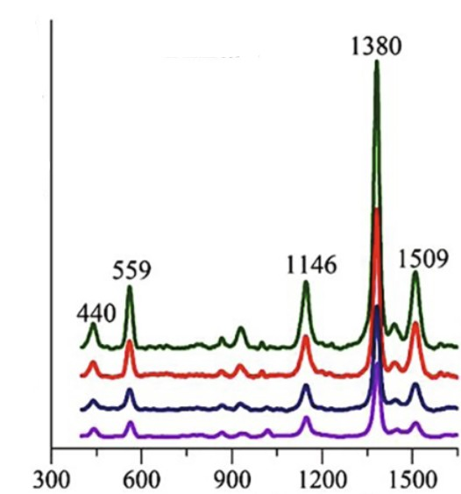

Figure 205: <https://doi.org/10.1016/j.foodchem.2021.129025>

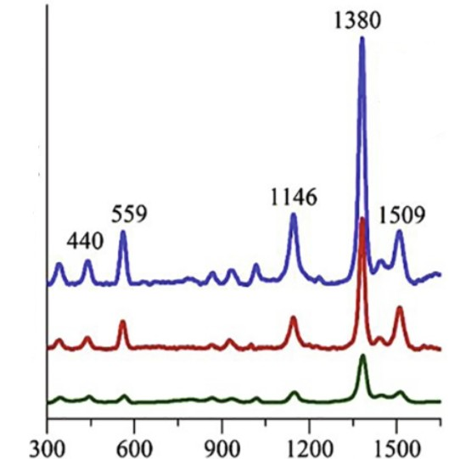

Figure 206: <https://doi.org/10.1016/j.foodchem.2021.129025>

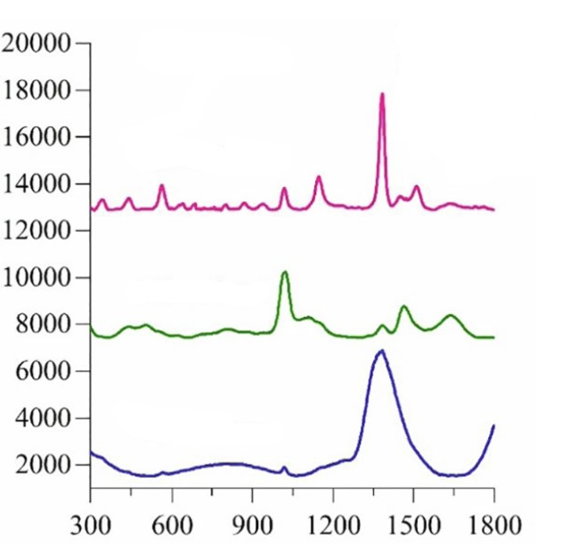

Figure 207: <https://doi.org/10.1016/j.foodchem.2021.129025>

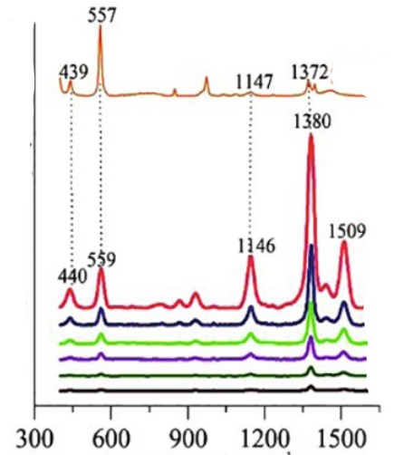

Figure 208: <https://doi.org/10.1016/j.foodchem.2021.129025>

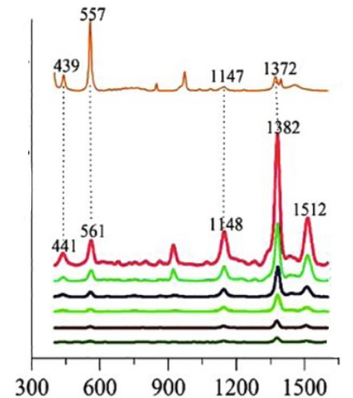

Figure 209: <https://doi.org/10.1016/j.foodchem.2021.129025>

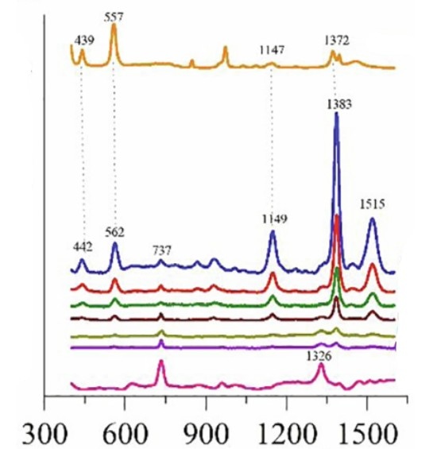

Figure 210: <https://doi.org/10.1016/j.foodchem.2021.129025>

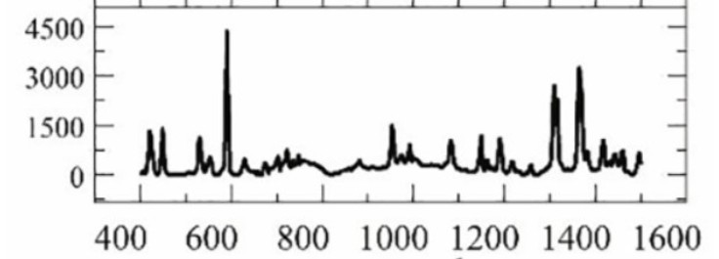

Figure 211: <https://doi.org/10.1016/j.foodchem.2021.129025>

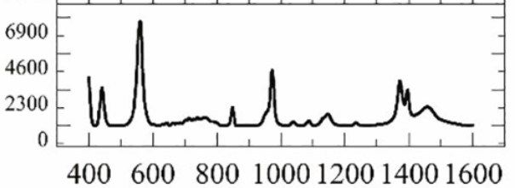

Figure 212: <https://doi.org/10.1016/j.foodchem.2021.129025>

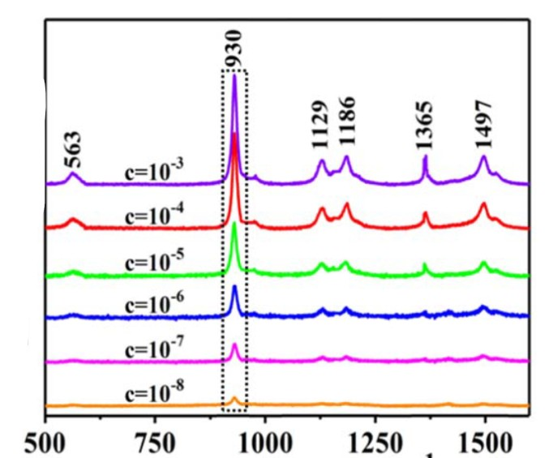

Figure 213: 10.1088/1361-6528/ab3a84

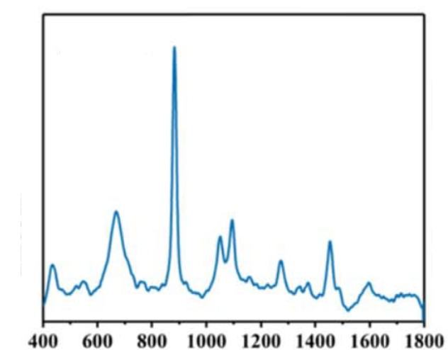

Figure 214: 10.1088/1361-6528/ab3a84

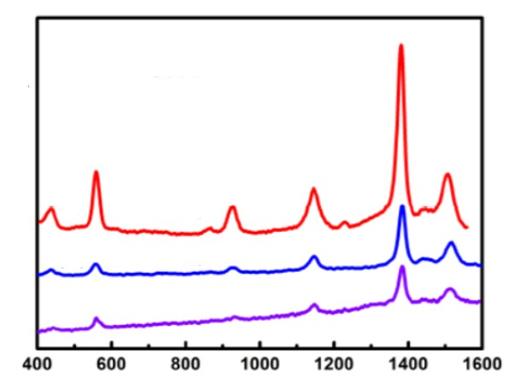

Figure 215: <https://doi.org/10.1021/acsami.7b13479>

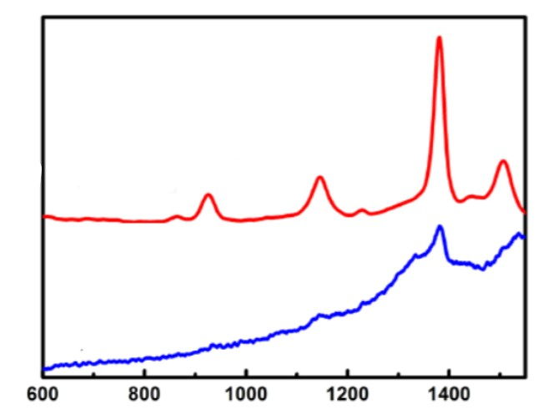

Figure 216: <https://doi.org/10.1021/acsami.7b13479>

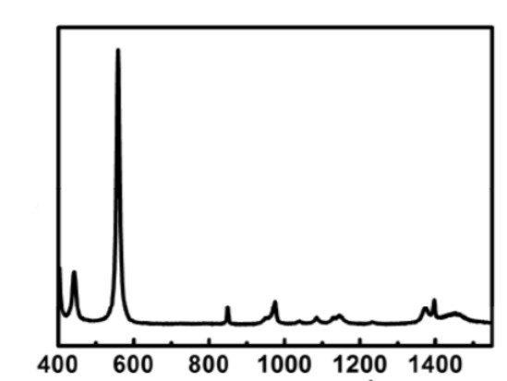

Figure 217: <https://doi.org/10.1021/acsami.7b13479>

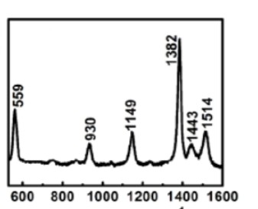

Figure 218: <https://doi.org/10.1021/acsami.7b13479>

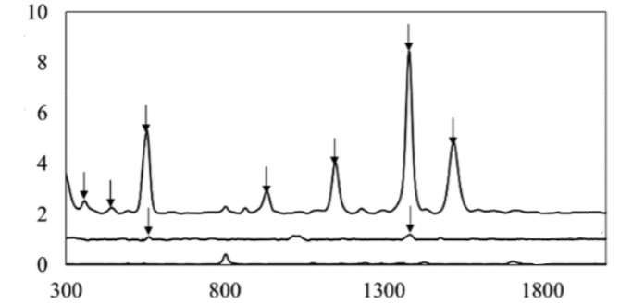

Figure 219: <https://doi.org/10.1021/acs.jafc.9b01544>

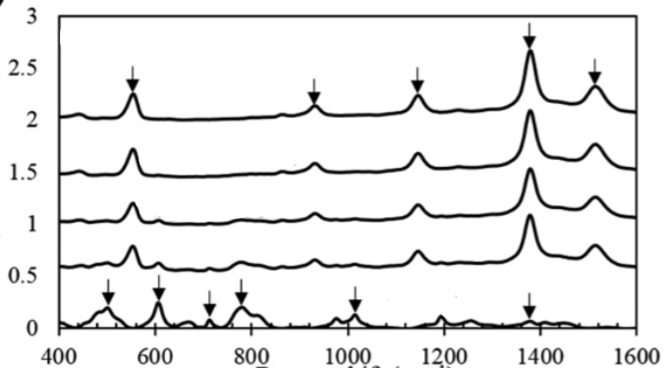

Figure 220: <https://doi.org/10.1021/acs.jafc.9b01544>

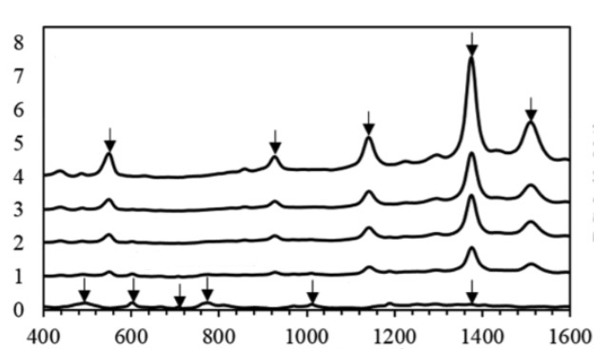

Figure 221: <https://doi.org/10.1021/acs.jafc.9b01544>

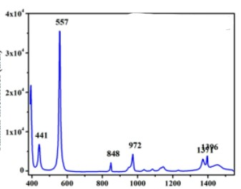

Figure 222: <https://doi.org/10.1177/18479804221082778>

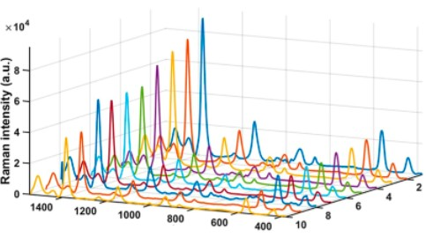

Figure 223: <https://doi.org/10.1177/18479804221082778>

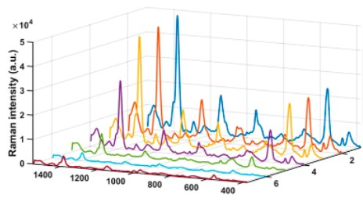

Figure 224: <https://doi.org/10.1177/18479804221082778>

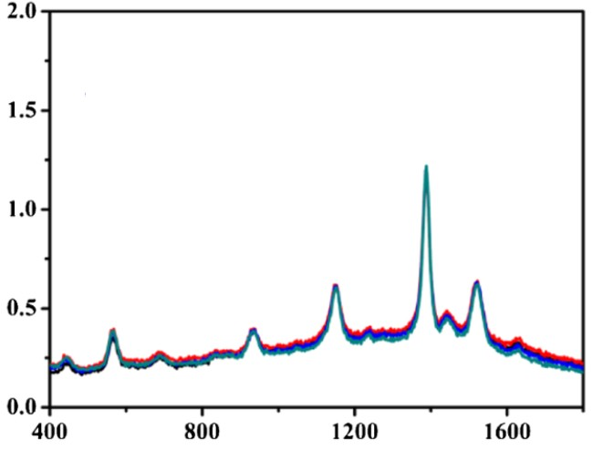

Figure 225: <https://doi.org/10.1007/s00604-019-3579-2>

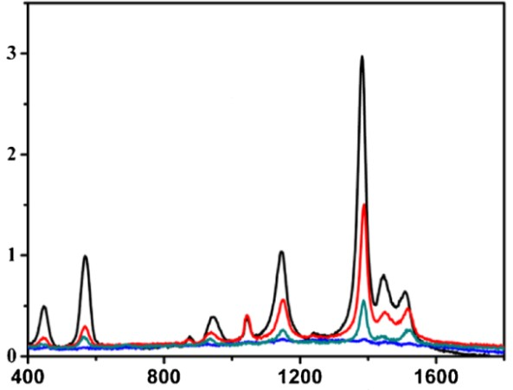

Figure 226: <https://doi.org/10.1007/s00604-019-3579-2>

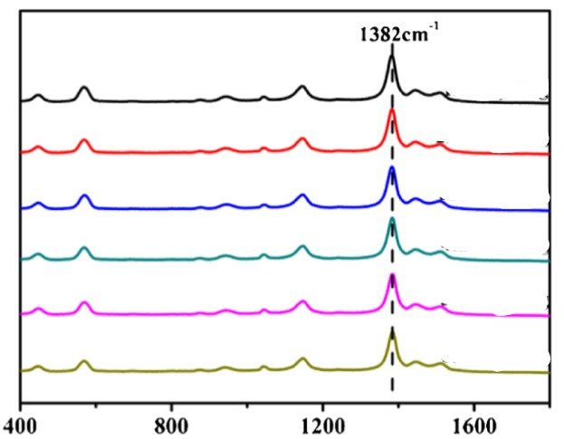

Figure 227: <https://doi.org/10.1007/s00604-019-3579-2>

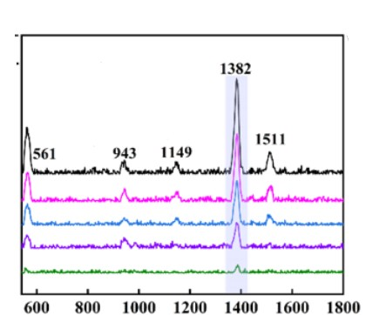

Figure 228: 10.1088/1742-6596/2961/1/012006

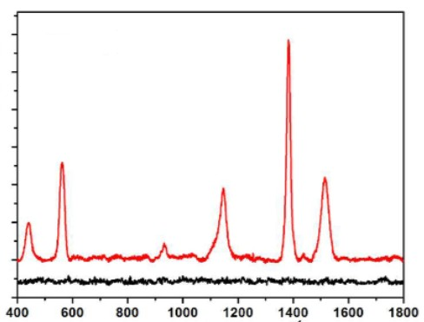

Figure 229: <https://doi.org/10.1021/acsami.7b04365>

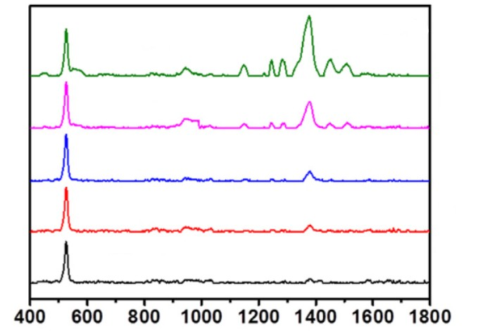

Figure 230: <https://doi.org/10.1016/j.apsusc.2020.147236>

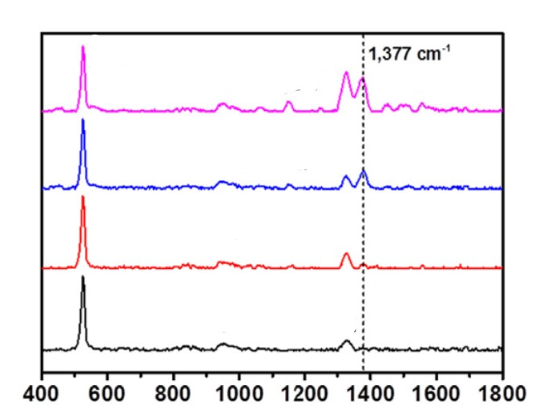

Figure 231: <https://doi.org/10.1016/j.apsusc.2020.147236>